ORDINARY LEVEL

535/3 PHYSICS

PRACTICAL WORK BOOK



**BY**

**The Department of physics @ MAJET Secondary School, 2019.**

**NAME:**

**CLASS:** **STREAM:**

**SCHOOL:**

|  |  |  |
| --- | --- | --- |
| ©2019 MAJET Secondary School Physics Department |  | 0 |

**TABLE OF CONTENTS**

INTRODUCTION 2

RECORDING OF PRACTICAL RESULTS 3

WORKED OUT EXAMPLES 12

MARKING GUIDE 20

MECHANICS EXPERIMENTS 21

LIGHT EXPERIMENTS 32

ELECTRICITY EXPERIMENTS 50

QUESTION PAPERS FOR UNEB AND MOCKS…………………………………………………………67



|  |  |
| --- | --- |
|  | 1 |



**1.0 INTRODUCTION TO PHYSICS PRACTICAL**

**1.1:** **INTRODUCTION 535/3 PHYSICS**

Physics is sometimes called the science of measurements because without observation and measurement it would not exist.

* In order to develop and test theories it is important to make measurements that are precise and accurate
* This workshop therefore discusses the recording of measurements and data manipulation at ordinary level (UCE).

**1.2** Ordinary Level Physics Practical course should enablestudents to:

* Carry out experiments on fundamental laws and principles encountered in the theoretical work e.g.

Hooke’s law, Snell’s law, Principle of moments etc.

* Carry out measurements in the determination of a wide variety of physical constants e.g. acceleration due to gravity, refractive index of glass or liquid, mass of a metre rule, density of a substance, internal resistance of a cell, focal length of a lens or mirror, resistance per metre of a wire.
* Gain experience of a variety of measuring instruments and learn to handle them with skills and also appreciate their limitations.

**1.3** Objectives of the practical exam are to test students on;

* The ability to handle apparatus and use measuring instruments effectively and safely
* The ability to plan the presentation of practical work
* The ability to interpret, evaluate and report upon observations and experimental data

**1.4** To students, each student should possess the followingscholastic materials;

* Long transparent rule, Scientific calculator, Geometrical set, Sharp pencil and a rubber, Graph paper

The duration of the Practical paper is 2 hours and 15 minutes. (15 minutes for reading and planning, 2 hours for working).

Question one – always mechanics question and compulsory Question Two – always light or heat

Question Three – always-current electricity

**Options**

Total number of questions to answer is **2**, each question is **30** marks, and whole paper is marked out of **60 marks**.

**PLANNING THE EXPERIMENT (15 MINUTES)**

* 1. The purpose is to help students to :
* Think ahead and plan, Set up the apparatus as shown in the diagram, Avoid making careless mistakes due to panic
* Properly record data with appropriate units
  1. The students therefore should :



* Read through the experiment , reflect on its objective and title
* Identify the quantities to be actually measured and those to be calculated or derived as well as the given quantities which control the experiments
* Draw a detailed columnar table of results for all the measurements that are to be repeated and their associate calculations.

**Note**

All values given to control the extent of performing the experiment should be filled in the first column of the table while keeping the order in which they are stated and the units

**Column headings (Table of results)**

* A closed columnar table of results with only three horizontal lines should be drawn.
* Al columnar headings must be labeled and should consist of a quantity and a unit or without a unit as the case may be.
* The unit is separated from the quantity by enclosing it in brackets .e. g a length ***l*** measured in centimetres may be represented as follows – *l* (cm) but not length *l* (cm).
* Avoid the use of equations in column headings especially

when the quantity has been defined, e. g when the extension is calculated from e= (P1-P0), the column heading should be e (cm) but not e= (P1-P0) (cm).

* However, (P1-P0) (cm) is a good column heading when the extension ***e*** is not defined.

|  |  |  |  |  |  |
| --- | --- | --- | --- | --- | --- |
| • | Avoid column headings such as *l1-l2* (cm) or | | | − | (cm) |
|  |
|  |  | − |  |  |
|  | rather use (*l1-l2*) (cm) and | (cm). |  |  |
|  |  |  |  |
|  |  |  |  |  |

* When a quantity has not been assigned a symbol, choose

an appropriate symbol or letter to represent it. e. g. suppose a step in the procedure reads :-

* Determine the time for 20 0scillations.
* Choose a letter, say, t, to represent the time for 20 oscillations, instead of writing time for 20 oscillations as a column heading.
* The first letter of the names of the quantity is usually preferred. t- for time, m- for mass, l-for length, h-for height, p-for pointer positions.

1. **Columns of calculated quantities.**

Some quantities can be calculated from a formula or given expression and you should not omit steps that lead to the final results of the formula e. g when asked to tabulate your results including values of :

* Cos2 , you must progress from to cos and then cos2 you must therefore have a column for , cos and then

|  |  |  |  |  |  |
| --- | --- | --- | --- | --- | --- |
| cos2 . For |  | progress from ***x*** to x2 | then | 2 | . |
|  |  |
|  |  |  |  | |

1. **Units of calculated quantities.**
   * Units of calculated quantities can be derived from the

formulae or equations that relate different quantities e.g. Column labeled can have the VA-1 OR Ω as its units.

|  |  |
| --- | --- |
|  | 2 |

**RECORDING PRACTICAL RESULTS**

The values recorded during the Physics Experiment Practical, are divided into three. i.e.

1. **Given values of varying quantity**: These are usuallygiven in the procedures. They must be recorded the way they are given in the instructions unless told to record otherwise.
2. **Experimental values** (or measured values): These arevalues of a varying quantity that are determined using an instrument. They are recorded to the accuracy of the instrument used .For example;

**Table A:**

|  |  |  |  |  |  |
| --- | --- | --- | --- | --- | --- |
| **Instrument** | **Quantity** | **Unit** |  | **Accuracy** | |
|  | **measured** |  |  | **(Number of** | |
|  |  |  |  | **decimal** | |
|  |  |  |  | **places)** | |
| Metre-rule & | Length | (cm) |  | **1 dp.** |  |
| Foot ruler |  |  |  |  |  |
| Stop clock | Time | (s) |  | **1 dp**. |  |
|  |  |  |  | (last digit | |
|  |  |  |  | **.0** or **.5**) |  |
|  |  |  |  | 8.0s, | 10.0s, |
|  |  |  |  | 22.5s, 55.0s | |
| Stop watch | Time | (s) |  | **2 dp.** |  |
|  |  |  |  | 1.20s, | 4.07s, |
|  |  |  |  | 50.00s, 54.38s. | |
| Ammeter | Current | (A) |  | **2 dp.** |  |
|  |  |  |  | 0.14A, | 0.22A, |
|  |  |  |  | 0.58A, 0.90A | |
| Voltmeter | Voltage | (V) |  | **2 dp.** |  |
|  |  |  |  | 0.35V, | 0.80V, |
|  |  |  |  | 1.25V, 2.95V | |
| Protractors | Angles | (0) |  | **0dp**. |  |
|  |  |  |  | e.g.19*°*, |  |
| Measuring | Volume | (cm3) |  |  |
| cylinders, |  | or | 50*°*, 87*°*, 32*°* | | |
| Burettes, |  | (ml) |  |  |  |
| Pipettes |  |  |  | 7ml,15ml, | |
|  |  |  |  | 49ml. |  |
| Thermometer | Temperature | 0C |  |  |  |

Row data consist of readings or measurements taken directly from a measuring instrument.

It should be expressed to a fixed number of decimal places dictated by the scale of the instrument the units used and the precision of the instrument.

All the raw reading of a particular quantity should be recorded to the same number of decimal places and should be consistent with the precision and accuracy of the apparatus

Each reading recorded from an instrument should consist of two parts namely:-



1. A numerical value recorded to the nearest smallest scale division.
2. Units.

**N.B**

When given an instrument for carrying out measurements one need to study the scale and establish the least Count or **What** **1 small scale division represents** and then **Units**.

**Recording measurements in an experiment**

* 1. Single measurement (The procedure does not require repeating)
* Examples of single measurement:
* Width of metre rule;
* Width of a glass block;
* Rough distance of the image of a distant object in a concave mirror or convex lens.
* Take the required measurement at least three times and then calculate the average of the measured values and give its value to the degree of accuracy of the measuring instrument.
* The measured results may be put in table and the average calculated outside the table.
* If the measurement is required to be recorded in SI units, then record all the values in S.I units before finding the average.
* In some cases a single measurement is taken once. For example, in experiments using a helical spring the initial position of the pointer before attaching a mass on it is recorded once.
  1. Repeated measurement (Certain steps of the procedure are required to be repeated for given values)
* These measurements are put in the main table of results to the accuracy of the instrument used.
* In any column the number of decimal places in that column must be the same.

The main table of results should have only values of varying quantities

Constant values of non-repeated quantity should be recorded before the main table of results.

1. **Derided quantity values**
   * The values of trigonometric ratios and logarithms are recorded to 3dp
   * **Calculated values:**

These are usually obtained from the experimental values.

(i) **Decimal Places**

The number of decimal places (dp) is the number of digits to the right end of a decimal point. E.g. the number 3.6420 is given to 4dp.Thus 3.6420 ≈ 3.642(3dp), 3.6420 ≈ 3.64(2dp),

|  |  |
| --- | --- |
| ©2019 MAJET Secondary School Physics Department | 3 |

3.6420 ≈ 3.6(1dp), 3 .6420 ≈ 4 (0dp).

**(ii) Significant Figures**

The Significant Figures of a number refer to those digits that have meaning in reference to a measured or specified value. Correctly, accounting for Significant Figures is important while performing arithmetic so that the resulting answers accurately represent numbers that have computational significance or value.

There are three rules that are used to determine how many significant figures are in a number. There are also rules for determining how many digits should be included in numbers computed using addition/subtraction, multiplication/ division, or a combination of these operations.

**Rules for determining how many Sig Figs are in a number: Rule #1**: **Non zero digits** (1–9). Every non zero digits in arecorded measurement is significant

Examples:- 5.39 has three significant figures, 1.892 has four significant figures, 1.37mm, 5.42cm, 99.8 cm are expressed to 3 s.f.

**Rule #2**: **Trapped zeros.** Zero between non-Zero digits aresignificant. Example; 4023 has four significant figures, 50014 has five significant figures, 10.5cm, 9.06cm, 2.04, 504 have 3 s.f

**Rule #3**: **Trailing zeros.**

* Zero at end of a number and to the right of decimal points is significant. Example: 1.00m, 0.300m, 2.50m, 10.0cm are expressed to 3 sf.
* Trailing zeros are not significant in numbers without decimal point. They just sense as place value holders to show the magnitude of a number. Example: 470000 has

2s.f, 400 has 1 sf, 300, 500, 80000, 1000000 are expressed to 1sf.

**Note. 39.9** rounded to **2sf** is **40.** [Please note the decimal pointat the end of the trailing zero. It makes the zero trapped and hence significant]

**Rule #4**: **Leading zeros.** Zeros to the left of the first non-Zerodigit are NOT significant. Example; 0.000034 has only 2 s.f, 0.001111 has 4 s.f, 0.0075m, 0.000089m, 0.00037m are expressed to 2 s.f

**Rules for determining the number of decimal places in a column:**

The number of decimal places or significant figures to which these values are to be recorded is obtained using the two basic rules of data manipulation. These are;

1. **Addition and subtraction of quantities.**

* The number of ***decimal places (dp)*** in the answer should be the same as the least number of dps in any of the numbers being added or subtracted. E.g.
* (i) 4.721 (3dp) + 1.18 (2dp) = .( )
  1. 420.03(2dp) + 299.270(3dp) + 99.068(3dp)
     + 818.368 =. ( 3dp ).

420.03 is the least precise (2 decimal places). So the answer 818.368 MUST BE rounded to 2 decimal places to give 818.37 (2Decimal place)

* 1. 504.009(3dp) + 246.8(1dp) − 119.32(2dp)
     + - . ( ). .

1. **Multiplication & division of quantities**

The number of ***significant figures (s.f)*** in the answer should be the same as the least number of s.f in any of the numbers being multiplied or divided. E.g.

|  |  |  |  |  |  |
| --- | --- | --- | --- | --- | --- |
| (i) | 5.90 | x | 0.05 | = | 0.3 |
|  | 3 s. f | x | (1s. f ) | = | (1s. f ) |
| (ii) | 7.0 | x | 0.560 | = 3.9 | |
|  | (2 s. f ) | x | (3 s. f ) | = (2 s. f ) | |

1. 1.80( 3 . ) = 18 (2 s. f )

0.10(2 . )

|  |  |  |  |  |
| --- | --- | --- | --- | --- |
| (iv) | 0.045 | × 0.00465 | (3s.f) | = 0.000050 (2sf) |
|  | 4.2 (2 sf) |  |  | |
|  |  |  |  |

**Note:**

1. **(53.4)2 = 2852 (0dp)** and not 2850 (3sf) as the rules couldhave predicted, because the value 2850 (3sf) would increase the error seriously.
2. **(2400)(3.45)(16.21) = 134218.8 = 134219**

The number 2400 only has 2 Sig Figs (and its the least no. of sfs), so the answer 134218.8 must be rounded to 2 Sf’s to give 130000. However, this creates a very large error, so we just round off to a whole number 134219.

Thus if the number of significant figures before a decimal point exceed those predicted by rule, then just round off to a **whole number (0dp).**

1. **A float;**

A float is a whole number or a constant, which has an infinite number of decimal places e.g. 1, 20, 100, etc. A float is not an experimental value. It’s only used in calculations and does not affect the number of significant figures. E.g.

|  |  |  |  |  |
| --- | --- | --- | --- | --- |
| (i) |  | 29.5 (3s.f ) | | = 1.48 (3 s. f ) |
|  |  |  |
|  |  | 20 (float value) | | |
|  |  |  | | |



|  |  |
| --- | --- |
|  | 5 |

**MANIPULATION OF DATA IN THE TABLE**

**Finding the number of significant figures for calculated values in the main table of results**

Largest value in the column (i.e **Largest product**, **Largest quotient**, or **Largest reciprocal**) to determine significant figures of the rest of the processed values in that column. Largest value has the largest number of significant figures.

**Example 1**

= .

|  |  |  |  |  |  |  |  |  |  |  |  |  |  |  |  |  |  |  |  |  |  |  |  |  |
| --- | --- | --- | --- | --- | --- | --- | --- | --- | --- | --- | --- | --- | --- | --- | --- | --- | --- | --- | --- | --- | --- | --- | --- | --- |
|  |  |  |  | | |  |  |  |  |  |  |  |  | |  |  | |  |  |  | |  |  |  |
|  |  | |  |  |  |
|  |  |  |  |  |  |  |  |  |  |  |  |  |  |  | |  |  |  |  |  |  |  |
|  | 0.05 |  | 26.1 | | | 0.261 | 0.01 | 0.003 | 0.19 | | |  | 0.10 | |  |  |  |  |  |  |  |  |  |  |
|  |  |  |  |  | |  |  |  |  | | |  |  | |  |  |  |  |  |  |  |  |  |  |
|  | 0.10 |  | 31.0 | | | 0.310 | 0.03 | 0.010 | 0.32 | | |  | 0.16 | |  |  |  |  |  |  |  |  |  |  |
|  |  |  |  |  | |  |  |  |  | | |  |  | |  |  |  |  |  |  |  |  |  |  |
|  | 0.15 |  | 38.0 | | | 0.380 | 0.06 | 0.023 | 0.39 | | |  | 0.20 | |  |  |  |  |  |  |  |  |  |  |
|  |  |  |  |  | |  |  |  |  | | |  |  | |  |  |  |  |  |  |  |  |  |  |
|  | 0.20 |  | 45.0 | | | 0.450 | 0.09 | 0.040 | 0.44 | | |  | 0.22 | |  |  |  |  |  |  |  |  |  |  |
|  |  |  |  |  | |  |  |  |  | | |  |  | |  |  |  |  |  |  |  |  |  |  |
|  | 0.25 |  | 53.2 | | | 0.532 | 0.13 | 0.063 | 0.47 | | |  | 0.23 | |  |  |  |  |  |  |  |  |  |  |
|  |  |  |  |  | |  |  |  |  | | |  |  | |  |  |  |  |  |  |  |  |  |  |
|  | **0.30** |  | **62.0** | | | **0.620** | **0.19** | 0.090 | 0.48 | | |  | **0.24** | |  |  |  |  |  |  |  |  |  |  |
|  |  |  |  |  |  |  |  |  |  |  |  |  |  |  |  |  |  | |  | |  |  |  |  |
| ❖ In the column of | | |  |  | , using the largest value in this column, | | | | | | | | we have**;** | | |  | . ( )× . ( ) | | | | = . ( ). Thus, all values in this | | | |
|  |  |  |  | . ( ) | |  |
|  |  |  |  |  |  |  |  |  |  |  |  |  |  |  |  |  |  |  |  |  |  |

column should be recorded to **2dp.**

* In the column of 2, using the largest value in the columns of ***x*** , we have; 0.30(2 ) × 0.30(2 ) = . (2 ). Thus, all values in the column of 2 should be recorded to **3dp.**

**Example 2**

= . ( )

|  |  |  |  |  |  |  |  |  |  |  |  |  |  |  |  |  |  |  |  |  |
| --- | --- | --- | --- | --- | --- | --- | --- | --- | --- | --- | --- | --- | --- | --- | --- | --- | --- | --- | --- | --- |
| ( ) | V(V) | I(A) |  | 1 |  | (V−1) |  | 1 | (A−1) |  |  | | |  |  | |  | 1 | (m−1) | IV W |
|  |  |  |  |  |  |  |  |  |  |  | Ω |  |  |  |  |  |  |
|  |  |  |  | V | | I |  |  |  |  | |  | y |  |
| 0.200 | 0.50 | 0.40 |  |  |  | **2.0** |  |  | 2.5 |  |  | 1.3 | | **6.0** | | |  |  | **5.00** |  |
|  |  |  |  |  |  |  |  |  |  |  |  |  | |  | | |  |  |  |  |
| 0.300 | 0.60 | 0.36 |  |  |  | 1.7 |  |  | 2.8 |  |  | 1.7 | | 5.0 | | |  |  | 3.33 |  |
|  |  |  |  |  |  |  |  |  |  |  |  |  | |  | | |  |  |  |  |
| 0.400 | 0.70 | 0.32 |  |  |  | 1.4 |  |  | 3.1 |  |  | 2.2 | | 4.3 | | |  |  | 2.50 |  |
|  |  |  |  |  |  |  |  |  |  |  |  |  | |  | | |  |  |  |  |
| 0.500 | 0.90 | 0.28 |  |  |  | 1.1 |  |  | 3.6 |  |  | 3.2 | | 3.3 | | |  |  | 2.00 |  |
|  |  |  |  |  |  |  |  |  |  |  |  |  | |  | | |  |  |  |  |
| 0.600 | 1.00 | 0.24 |  |  |  | 1.0 |  |  | 4.2 |  |  | 4.2 | | 3.0 | | |  |  | 1.07 |  |
|  |  |  |  |  |  |  |  |  |  |  |  |  | |  | | |  |  |  |  |
| 0.700 | 1.10 | 0.20 |  |  |  | 0.9 |  |  | **5.0** |  |  | **5.5** | | 2.7 | | |  |  | 1.43 |  |
|  |  |  |  |  |  |  |  |  |  |  |  |  |  |  |  |  |  |  |  |  |

* In the column of , the values are given precisely to 3 d.p. In the column of , the values of voltage were measured from a voltmeter to the accuracy of 2dp. Similarly, In the column of , the values of current were measured from an ammeter to the accuracy of 2dp.

|  |  |  |  |  |  |  |  |  |  |
| --- | --- | --- | --- | --- | --- | --- | --- | --- | --- |
| ❖ | In the column of | 1 | | | , using the largest value in this column, we have; |  |  | | = . ( ). Thus, all values in this column |
|  |  | | . ( ) | |  |
|  |  |  |  |  |
|  | should be recorded to **1 dp.** | | | | |  |  |  |  |
| ❖ | In the column of | 1 | |  | , using the largest value in this column , we have; |  |  | | = . ( ). Thus, all values in this column |
|  | I | |  | . ( ) | |
|  |  |  |  |  |  |

should be recorded to **1 dp.**

❖ In the column of VI , using the largest value in this column, we have; . ( ) = . ( ). Thus, all values in this column should be recorded to **1 dp.**

❖ In the column of 1 , using the largest value in this column (**Largest Reciprocal of y,** Use Least value in the column o**f y**), Hence,

we have; . ( ) = . ( ). Thus, all values in this column should be recorded to **2 dp.**

6

|  |  |  |  |  |  |  |  |  |  |  |
| --- | --- | --- | --- | --- | --- | --- | --- | --- | --- | --- |
|  | **Example 3.** | |  |  |  |  |  |  |  |  |
|  |  |  |  |  |  |  |  |  |  |  |
|  |  | ( ) | 3( 3) | ( ) | T( ) | T2 2 |  | 1 | −2 |  |
|  |  |  |  |  |  |  |  | T2 |  |
|  |  | . ( ) | . ( ) | . ( ) | .( ) | .( ) |  |  |  |  |
|  |  | These values |  | These values |  |  |  |  |  |  |
|  |  | were given | (3 sf) | were | (4 sf) | (4 sf) |  |  |  |  |
|  |  | precisely to |  | obtained |  |  |  |  |  |  |
|  |  | 3d.p |  | from a stop |  |  |  |  |  |  |
|  |  |  |  | watch to 2d.p |  |  |  |  |  |  |
|  |  |  |  |  |  |  |  |  |  |  |
|  |  | 0.400 | 0.0640 | 6.50 | 0.3250 | 0.1056 |  |  |  |  |
|  |  |  |  |  |  |  |  | | |  |
| ❖ | In the Column of **;** Using the largest value in the column of , we have; 0.900(3 ) × 0.900(3 ) × 0.900(3 ) = 0.729(3 ). | | | | | | | | | |
|  | Thus all values in the column of should be recorded to **3dp.** | | | |  |  |  |  |  |  |

❖ In the Column of **;** Using the largest value in the column of , we have; 17.75(4 ) = 0.8875(4 ). Thus, all values in the column



20

of should be recorded to **4dp.**

* In the Column of **;** Using the largest value in the column of T , we have; 0.8875(4 ) × 0.8875(4 ) = 0.7877(4 ). Thus, all values in the column of should be recorded to **4dp.**

**Example 4.**

|  |  |  |  |  |  |  |
| --- | --- | --- | --- | --- | --- | --- |
| u(cm) | v(cm) | (u+v) (cm) | uv(cm2) |  |  |  |
|  |  |  |  |  |  | |
|  |  |  |  |  | | |
| 20.0 | **66.6** |  | **1332** | **3.33** | | |
| 25.0 | 41.7 |  | 1043 | 1.67 | | |
| 30.0 | 32.8 |  | 984 | 1.09 | | |
| 35.0 | 28.5 |  | 998 | 0.81 | | |
| 40.0 | 26.5 |  | 1060 | 0.66 | | |
| 45.0 | 24.2 |  | 1089 | 0.54 | | |
|  |  |  |  |  |  |  |

* For ***uv*** **:** Using the **largest product**, Largest value in this column, we have: 20.0(3 ) × 66.6(3 ) = ( ) . Thus, all values in the column of should be recorded to **0dp.**

❖ For

|  |  |  |  |  |
| --- | --- | --- | --- | --- |
| **:** Using the **largest quotient**, in this column, we have: | 66.6(3 ) | = . ( ). Thus, all values in the column of |  | should be |
| 20.0(3 ) |  |
|  |  |  |

recorded to **2dp.**

|  |  |  |  |  |  |  |  |  |  |  |  |  |  |  |  |  |  |  |  |  |
| --- | --- | --- | --- | --- | --- | --- | --- | --- | --- | --- | --- | --- | --- | --- | --- | --- | --- | --- | --- | --- |
|  | (0) |  |  | (0) |  | ( ) | | ( ) |  |  |  |  | ( ) | |  | sin2*i* | 1 | |  |  |
|  |  |  |  |  |  |  |  |  |  |  |  |  |  |  |  |  |  | 2 |  |  |
|  | 10 |  |  | 6 |  |  | 0.8 | 7.0 | 0.156 |  |  | **0.996** | 0.8 |  |  |  |  |  |  |  |
|  | 20 |  |  | 14 |  |  | 1.6 | 7.2 | 0.342 |  |  | 0.970 | 1.6 |  |  |  |  |  |  |  |
|  | 30 |  |  | 20 |  |  | 2.4 | 7.4 | 0.500 |  |  | 0.940 | 2.3 |  |  |  |  |  |  |  |
|  | 40 |  |  | 28 |  |  | 3.5 | 7.8 | 0.643 |  |  | 0.883 | 3.1 |  |  |  |  |  |  |  |
|  | 50 |  |  | 30 |  |  | 4.0 | 8.1 | 0.766 |  |  | 0.866 | 3.5 |  |  |  |  |  |  |  |
|  | 60 |  |  | 35 |  |  | 4.8 | 8.5 | **0.866** |  |  | 0.819 | **3.9** |  |  |  |  |  |  |  |
| For | |  | | : | Using | | the | largest | product | in | | this | column | of | | , | We | | have: | |
| . ( ) × . ( ) = . ( ). Hence values in the column of | | | | | | | | | | | | shouldbe recorded to. | | | | |  |  |  |  |

7

**Example 4**

Given that the-values of *f0*(cm), *x*l(cm) and *x*2(cm)are experimental values, all measured using a meter rule. Complete the table of results for values of *l* (cm), *d* (cm), *d*2(cm2)and (*l*2-*d*2) (cm2);where *d* = (X2- Xl) and *f0*= 10.0cm.

**SOLUTION**

|  |  |  |  |  |  |  |  |
| --- | --- | --- | --- | --- | --- | --- | --- |
| ***l(cm)l(cm)x*** | | **l (cm)** | ***x*2(cm)** | ***d*(cm)** | ***l*2(cm2)** | ***d*2(cm2)(*l*2-*d*2) (cm2)** | |
|  |  |  |  |  |  |  |  |
| 6.5f0 | **65** | **52.0** | 8.8 | -43.2 | **4225** | **1866** | **2359** |
|  |  |  |  |  |  |  |  |
| 6.0f0 | 60 | 46.6 | 9.2 | -37.4 | 3600 | 1399 | 2201 |
|  |  |  |  |  |  |  |  |
| 5.5f0 | 55 | 36.2 | 11.0 | -25.2 | 3025 | 635 | 2390 |
|  |  |  |  |  |  |  |  |
| 5.0f0 | 50 | 41.1 | 10.0 | -31.1 | 2500 | 967 | 1533 |
|  |  |  |  |  |  |  |  |
| 4.5f0 | 45 | 30.0 | 11.9 | -18.1 | 2025 | 328 | 1697 |
|  |  |  |  |  |  |  |  |
| 4.0f0 | 40 | 24.9 | **13.0** | **-11.9** | 1600 | 142 | 1458 |
|  |  |  |  |  |  |  |  |

To determine the number of decimal places for the values in a given column we first determine the number of decimal places for the leading value in the column (i.e. by using the rules for data manipulation) and then we write the remaining values to the same number of decimal places.

***How the numbers of decimal places for the calculated values in the above table of results were determined.***

* Values of *x*1, and *x*2 are experimental values obtained using a meter rule. They must be recorded to the accuracy of the meter rule (i.e. **1dpl).**
* In the column for *l*, using the largest value we've;

6.5*f0* = 6.5(2s.f) x 10.0(3s.f) = 65(2s.f).

Since the largest value is to 2sf, all the values in the column of *l (cm)* should be written to **2dp**.

* In the column for d, using the largest value (-43.2), we've; *d* = *x*2–*x*1

*d* = 13.0(ldp)-24.9(ldp)= - 11.9(ldp)..

All the values in the column of *d* (cm) should therefore be written to **1dpl**.

* In the column for *d*2, using the largest value we've;

*d*2= (-43.2)2=(-43.2)(3s.f's)x (-43.2)(3Sf's), *d*2= 1866.24**≈**1866(0dp)

It is important to note that the value 1866.24 is supposed to be written to 3sf's (if we follow the rule for multiplication). However, if the value 1866.24 is written to 3sf's we get 1870. In this case, the error created due to rounding off is quite big. Thus to minimize the rounding off error, we round this number off but write it as a whole number i.e. round it off to remove the decimal.

Thus, we write 1866.24 ≈ 1866(**0dpl**). Since the leading value is to 0dpl, all the values in the column should be to 0dpl.

* In the column for *l*2, using the largest value we've;

*l*2=65.0(3s.f)x 65.0(3s.f)= 4225(3s.f)

Thus, all values in the column should be written to **0dp**l.

* In the column for (*l*2-d2),using the largest value we have;

(*l*2-d2) = 4225(0dpl) - 1866(0dpl) = 2359(0dpl).

Thus, all values in the column should be written to **0dpl**

**Note:**

* *The above rules only apply to the largest value in a column or columns under consideration.*
* *For uniformity, all values in a particular column in the table must be written to the* ***same number of decimal******places as the largest value in that column.***
* *In case the number of significant figures before a decimal point exceeds those predicted by the rules, then just round of to the nearest whole number.*
* *If the rules give constant values in a column, then increase the number of significant figures by one.*

**Complete the tables bellow using the rules of data manipulation above.**

|  |  |  |  |  |  |  |  |  |  |  |  |  |  |  |  |  |  |
| --- | --- | --- | --- | --- | --- | --- | --- | --- | --- | --- | --- | --- | --- | --- | --- | --- | --- |
| **Question 1** | | |  |  |  |  |  |  |  |  |  |  |  |  |  |  |  |
|  |  |  |  | |  | | | |  |  |  | − | | | |  |  |
|  |  |  |  |  |  |  |  |  |  |  |  |  |  |
|  |  |  |  |  |  |  |  |  |  |  |  |  |  |
|  |  |  |  |  |  |  |  |  |  |  |  |  |  |  |  |  |
|  |  |  |  |  |  |  |  |  |  |  |  |  |  |  |  |  |  |
|  |  |  | 10.0 | | 0.32 | | | |  |  |  |  |  |  |  |  |  |
|  |  |  | 20.0 | | 0.30 | | | |  |  |  |  |  |  |  |  |  |
|  |  |  | 30.0 | | 0.28 | | | |  |  |  |  |  |  |  |  |  |
|  |  |  | 40.0 | | 0.26 | | | |  |  |  |  |  |  |  |  |  |
|  |  |  | 50.0 | | 0.22 | | | |  |  |  |  |  |  |  |  |  |
|  |  |  | 60.0 | | 0.20 | | | |  |  |  |  |  |  |  |  |  |
| **Question 2** | | |  |  |  |  |  |  |  |  |  |  |  |  |  |  |  |
|  |  | |  |  |  |  |  | | − | | |  |  |  | | − | |
|  |  |  |  |  |  |  |  |  |  |  |  |  |
|  |  |  |  |  |  |  |  | |  |  |  | |
|  |  |  |  |  |  |  |  |  |  |  |  |  |  |
|  |  |  |  |  |  |  |  |  |  |  |  |  |  |  |  |  |  |
|  | 30.0 |  |  | 0.90 |  |  |  |  |  |  |  |  |  |  |  |  |  |
|  | 40.0 |  |  | 0.95 |  |  |  |  |  |  |  |  |  |  |  |  |  |
|  | 50.0 |  |  | 1.15 |  |  |  |  |  |  |  |  |  |  |  |  |  |
|  | 60.0 |  |  | 1.35 |  |  |  |  |  |  |  |  |  |  |  |  |  |
|  | 70.0 |  |  | 1.55 |  |  |  |  |  |  |  |  |  |  |  |  |  |

**Table 1:**

|  |  |  |  |  |
| --- | --- | --- | --- | --- |
| *x*(cm) | *x*2(cm2) | *l*(cm) | *l*2(cm2) | (*x2-l2*) (cm2) |
| 85.0 |  | 48.6 |  |  |
|  |  |  |  |  |
| 75.0 |  | 42.1 |  |  |
|  |  |  |  |  |
| 70.0 |  | 33.5 |  |  |
|  |  |  |  |  |
| 65.0 |  | 29.7 |  |  |
|  |  |  |  |  |
| 60.0 |  | 18.4 |  |  |
|  |  |  |  |  |
| 55.0 |  | 15.8 |  |  |
|  |  |  |  |  |

8

**Table 2:**

|  |  |  |  |  |  |  |  |  |  |  |  |  |  |  |  |
| --- | --- | --- | --- | --- | --- | --- | --- | --- | --- | --- | --- | --- | --- | --- | --- |
|  |  |  |  |  |  | 2 | 2 |  | 3 | 3 | 1 | | -2 |  |  |
| *l*(m) | t(s) |  | T(s) | |  | T (s ) | |  | *l* | (m ) |  |  |  |  |
|  |  |  |  |  |  |  |  |  |  |  |  | T2 | (s | ) |  |
| 0.9 | 17.75 |  |  |  |  |  |  |  |  |  |  |  |  |  |  |
|  |  |  |  |  |  |  |  |  |  |  |  |  |  |  |  |
| 0.8 | 15.25 |  |  |  |  |  |  |  |  |  |  |  |  |  |  |
|  |  |  |  |  |  |  |  |  |  |  |  |  |  |  |  |
| 0.7 | 12.94 |  |  |  |  |  |  |  |  |  |  |  |  |  |  |
|  |  |  |  |  |  |  |  |  |  |  |  |  |  |  |  |
| 0.6 | 10.62 |  |  |  |  |  |  |  |  |  |  |  |  |  |  |
|  |  |  |  |  |  |  |  |  |  |  |  |  |  |  |  |
| 0.5 | 8.40 |  |  |  |  |  |  |  |  |  |  |  |  |  |  |
|  |  |  |  |  |  |  |  |  |  |  |  |  |  |  |  |
| 0.4 | 6.50 |  |  |  |  |  |  |  |  |  |  |  |  |  |  |
|  |  |  |  |  |  |  |  |  |  |  |  |  |  |  |  |
| **Table 3:** |  |  |  |  |  |  |  |  |  |  |  |  |  |  |  |
| *d*(cm) | 2θ(0) | θ(0) | | 20T(s) | | | T(s) | | T2(s2) | | cos | | |  |  |
|  |  |  |  |  |  | |  |  |  |  |  |  |  |  |  |
| 70 | 120 |  |  |  | 24.33 | |  |  |  |  |  |  |  |  |  |
|  |  |  |  |  |  | |  |  |  |  |  |  |  |  |  |
| 60 | 95 |  |  |  | 26.30 | |  |  |  |  |  |  |  |  |  |
|  |  |  |  |  |  | |  |  |  |  |  |  |  |  |  |
| 50 | 76 |  |  |  | 27.90 | |  |  |  |  |  |  |  |  |  |
|  |  |  |  |  |  | |  |  |  |  |  |  |  |  |  |
| 40 | 60 |  |  |  | 28.62 | |  |  |  |  |  |  |  |  |  |
|  |  |  |  |  |  | |  |  |  |  |  |  |  |  |  |
| 30 | 46 |  |  |  | 29.42 | |  |  |  |  |  |  |  |  |  |
|  |  |  |  |  |  | |  |  |  |  |  |  |  |  |  |
| 20 | 32 |  |  |  | 29.70 | |  |  |  |  |  |  |  |  |  |
|  |  |  |  |  |  |  |  |  |  |  |  |  |  |  |  |

1. Plot a graph of T2 against cos
2. Find the slope S of your graph.

**Table 4:**

|  |  |  |  |  |
| --- | --- | --- | --- | --- |
| *t*(cm) | *x*(cm) | y(cm) | *x*2(cm2) | y2(cm2) |
| 1.5 | 1.7 | 2.6 |  |  |
|  |  |  |  |  |
| 1.7 | 2.1 | 3.2 |  |  |
|  |  |  |  |  |
| 1.9 | 2.3 | 3.6 |  |  |
|  |  |  |  |  |
| 2.1 | 2.5 | 3.8 |  |  |
|  |  |  |  |  |
| 2.3 | 2.8 | 4.2 |  |  |
|  |  |  |  |  |
| 2.5 | 3.0 | 4.6 |  |  |
|  |  |  |  |  |

1. Plot a graph ofy2 against *x*2
2. Find the slope s of your graph.
3. Compute the critical angle C, of the glass from the expression;

|  |  |  |  |  |  |  |  |
| --- | --- | --- | --- | --- | --- | --- | --- |
|  |  | = − | |  | √ | |  |
|  |  |  |  |
|  |  |  |  |  |  |  |
| **Table 5:** |  |  |  |  |  |  |  |
| *x*(m) | *x*2(m2) |  | 20T(s) | |  | T(s) | T2(s2) |
|  |  |  |  |  |  |  |  |
| 0.10 |  |  | 14.5 |  |  |  |  |
|  |  |  |  |  |  |  |  |
| 0.15 |  |  | 15.0 |  |  |  |  |
|  |  |  |  |  |  |  |  |
| 0.20 |  |  | 16.0 |  |  |  |  |
|  |  |  |  |  |  |  |  |
| 0.25 |  |  | 17.0 |  |  |  |  |
|  |  |  |  |  |  |  |  |
| 0.30 |  |  | 18.5 |  |  |  |  |
|  |  |  |  |  |  |  |  |
| 0.35 |  |  | 20.0 |  |  |  |  |
|  |  |  |  |  |  |  |  |

1. Plot a graph of T2 against *x*2
2. Determine the intercept, C on the T2 – axis.
3. Find the slope S of your graph.

**Table 6:**

|  |  |  |  |  |  |
| --- | --- | --- | --- | --- | --- |
| **d(cm)** | **d2(cm2)** | **y1(cm)** | **y2(cm)** | **(y2- y1)(cm)** | **(y2- y1)2(cm2)** |
|  |  |  |  |  |  |
| 41.0 |  | 15.3 | 24.6 |  |  |
|  |  |  |  |  |  |
| 46.0 |  | 13.5 | 31.8 |  |  |
|  |  |  |  |  |  |
| 51.0 |  | 12.5 | 37.5 |  |  |
|  |  |  |  |  |  |
| 56.0 |  | 11.8 | 42.7 |  |  |
|  |  |  |  |  |  |
| 61.0 |  | 11.5 | 48.1 |  |  |
|  |  |  |  |  |  |
| 66.0 |  | 11.0 | 53.4 |  |  |
|  |  |  |  |  |  |

1. Include values of**d2- (y2-** **y1)2.**
2. Plot a graph ofd2- (y2- y1)2 against d.
3. Find the slope, S of your graph.
4. Calculate the focal length of the convex lens from; **S= 4f.**

**Table 7:**

|  |  |  |  |  |  |  |  |  |
| --- | --- | --- | --- | --- | --- | --- | --- | --- |
| R(Ω) |  | *l*(cm) |  | 100 − ( ) | |  | (100 − ) |  |
|  |  |  |  |  |  |  |  |  |
|  |  |  |  |  |  |  |  |  |
| 1 |  | 75.0 |  |  |  |  |  |  |
|  |  |  |  |  |  |  |  |  |
| 2 |  | 60.9 |  |  |  |  |  |  |
|  |  |  |  |  |  |  |  |  |
| 3 |  | 50.9 |  |  |  |  |  |  |
|  |  |  |  |  |  |  |  |  |
| 4 |  | 44.1 |  |  |  |  |  |  |
|  |  |  |  |  |  |  |  |  |
| 5 |  | 38.4 |  |  |  |  |  |  |
|  |  |  |  |  |  |  |  |  |
| 6 |  | 34.4 |  |  |  |  |  |  |
|  |  |  |  |  |  |  |  |  |
| a) | Plot a graph of | | | 100− | against R | |  |  |
|  |  |  |
|  |  |  |  |  |  |  |  |

1. Determine the slope S of the graph
   1. Find the unknown resistance Rs from the expression

=

**Table 8:**

|  |  |  |
| --- | --- | --- |
| *i*(0) | *r*(0) | *l*(cm) |
|  |  |  |
| 10 | 6 | 6.5 |
|  |  |  |
| 20 | 13 | 6.6 |
|  |  |  |
| 30 | 20 | 6.8 |
|  |  |  |
| 40 | 26 | 7.1 |
|  |  |  |
| 50 | 30 | 7.4 |
|  |  |  |
| 60 | 36 | 7.9 |

1. Plot a graph of 12 against sin2*i*
2. Find the slope K of the graph.
3. Read and record the intercept C on the 12 axis.
4. Calculate the width w of the glass block from the expression:

=

1. Determine the refractive index of the glass block from the expression;

= −

9

**GRAPH WORK**

1. ***Title of the graph at the top of the graph paper.***

* Clearly written in only 1 line e.g. A graph of T2 Against *x*2(i.e. T2plotted along the vertical axis &*x*2along thehorizontal axis).
* No units should be included in the title.
* Must be noted as given in the procedures or instruction requiring you to plot the graph.

(ii) ***Axes***

* Must be drawn perpendicularly to each other with an arrow at the end of each axis.
* Each axis must be clearly and correctly labeled with the quantity and unit in brackets.
* It must be clearly marked every after 10 small squared (2cm) starting from the origin.
* The starting point of each axis must be clearly shown.

***(*iii) *Intercepts***

* The intercept on a particular axis is the value for the quantity plotted along that axis for which, the quantity plotted along the other axis is zero.
* Therefore, if the intercept on the vertical (y – axis) is required, the starting point on the vertical can be anywhere (i.e. any value slightly below the smallest value in the column to be plotted on that axis) but the horizontal axis (x-axis) must start from zero. Similarly, if the intercept on the horizontal axis is required, then the vertical axis must begin from zero.

**(iv) *Scale***

**Obtaining the Suitable Convenient Scale**

A scale is **suitable** if it covers at least 50% of the graph paper. It is **convenien**t if it is easy to plot and follow. It is **consistent** along an axis, if it is uniform (has equal intervals) along that axis.

Obtain the range on both vertical axis (VA) and horizontal axis (HA).

|  |  |  |  |  |  |  |  |  |  |  |  |  |  |  |  |
| --- | --- | --- | --- | --- | --- | --- | --- | --- | --- | --- | --- | --- | --- | --- | --- |
|  | Where;= | | | |  | | | | | – |  | | | | |
|  |  | | | | |
|  |  |  |  |  |  | |  | |  |  |  |  | |  |  |
|  | PROCEDURES | | |  | HORIZONTAL | | | | |  |  | VERTICAL | | | |
|  |  |  |  |  | 1 |  | Range on H. A | | |  | 1 | Range on V. A | | | |
|  |  |  | |  |  |  |  | No. ssq |  |  |  |  | No. ssq |  | |
|  |  |  |  |  |  |  |  |  |  |  |  |  |  |
|  |  |  |  |  |  |  |  |  |  |  |  |  |  |  |
|  | . |  |  | 1 |  | | Rang eon H. A | |  | 1 | | Range on V. A | | |
|  |  |  |  |  |  |  |  |  |  |  |
|  |  |  |  |  | 80 |  |  | 100 |  |  |
|  |  |  |  |  |  |  |  |  |  |  |  |  |  |
|  |  |  |  |  |  |  |  |  |  |  |  |  |  |  |  |

**(This gives what one smallest square represents on each axis of the graph)**

* For convenience use digits **1, 2, 2.5** and **5** then **submultiples** e.g. 0.1, 0.2, 0.25 and 0.5; 0.01, 0.02, 0.025,and 0.05 etc. and the **multiples** e.g. 10, 20, 25 and 50, 100, 200, 250 and 500, etc.

**Note**: 4 & 8 are however not convenient digits though they areat times used.

❖ If the value of does not fall exactly on one of the

.

convenient scales, take the nearest **upper** value from the set of convenient scales (i.e. the scale should be rounded to the nearest greater (upper) suitable value of **one** **significant figure**.

* In case the first nonzero digit is 1, make it 2. If it is 2, 3 or 4, make it 5. If it is 5, 6, 7, 8, or 9, make it 10.

|  |  |  |  |  |  |  |
| --- | --- | --- | --- | --- | --- | --- |
| 1; | **2** |  | 2, 3, 4; | **5** | 5, 6, 7, 8, 9; | **10** |
|  |  |  |  |  |  |  |
| **1**.011; | **2** |  | 0.**1**1344; | **0.2** | 0.0**1**5432 | **0.02** |
|  |  |  |  |  |  |  |
| **2**.021; | **5** |  | 0.**3**1344; | **0.5** | 0.0**4;**5432 | **0.05** |
|  |  |  |  |  |  |  |
| **5**.57 | **10** |  | 0.**6**789 | **1** | 0.0**7**432 | **0.1** |
|  | |  |  |  |  |  |
| 0.00**9**95432 | |  | **0.01** |  |  |  |



* Multiply by 10 to get what 2cm (10small squares) represent.
* If the interval between zero and the 1st reading is extremely bigger than the interval between the first reading and second reading, then the first reading or lowest value should be shifted closely to the origin or to the starting point of that axis.

**Choosing the starting value along each axis**

* When marking the axes, if the question does not involve finding the intercept, the starting value should not necessarily be zero. Start from **a convenient** value which **is smaller than** and **a bit distant from** the smallest valuein the column.
* The starting value on any axis should be a multiple of the scale on that axis.
* There are only two cases where the starting value on a given axis must be zero, 0. These are:
  1. When the smallest value (top or bottom value) in a column is very close to zero.
  2. When an intercept is required on the other (perpendicular) axis.
* In order to plot a point accurately on a particular axis, get the value to be plotted from the main table of results (without rounding off), subtract the nearest value on that axis from the value to be plotted, and then divide the result by the scale of that axis. This gives the number of smallest squares to be counted from the chosen nearest value when plotting that value.

e***. Line of best fit or best curve***

Either the plotted points lead to a curve or best straight lines. In the case of a straight, then it should be a line through most of the points leaving almost equal no. of points on either side

10

if the points are scattered. This line should be produced long enough to cut the axis.

f. ***Slope***

When finding the slope, a large triangle covering all the plotted points is drawn. The points to be used to find the slope should be correctly read and written on the graph.

( ) , = ( )

Slope  ΔHorizontaΔVerticall

The slope should have the appropriate units obtained from the quantities of the labeled axes, except when it is a ratio of quantities of the same unit.

❖ **Calculation**

Before substituting any quantity in the formula or expression, it must be converted to S.I units first. The values should be correctly substituted in the given expression.

* The accuracy of the final answer should be that of the least accurate measurement involved in the calculation. (i.e. put into account the rules of data manipulation).

Put the units of the quantity under investigation if any.

**MEASUREMENT OF TIME**

The instruments commonly used for measuring time in the laboratory are the stop clock and stop watch. Before using these instruments, ensure that the initial reading is zero.

**Stop clock**

* It measures time in seconds. 1 small division on the scale of stop clock=1s OR 1 small division = 0.5s
* It is possible to estimate time to 1 d.p with both Stop Clocks.
* Both Clocks record time to 1 d.p and the last digits in any values should be a 0 or 5. Typical Values are 8.0s, 10.0s, 22.5s, 55.0s

**(i)** **Stop watch**

The stop watch measures time in seconds(s) to two decimal places. All values of time obtained using a stop watch must be recorded to two decimal places e.g. 7.23, 25.56, 48.89 etc.

* The Stop Watch records time to the nearest 0.01s (2 d.p)
* Every reading recorded with this Stop watch must therefore be recorded to 2 d.p. Typical readings 1.20s, 4.07s, 50.00s, 54.38s. Wrong readings 7.321s, 20s, 41.6s, 48.0s

**Note :** The stop watch may give values of time inminutes, seconds and microseconds. These values should be converted and recorded in seconds. Values of time

11

should be recorded in minutes only when required in minutes.

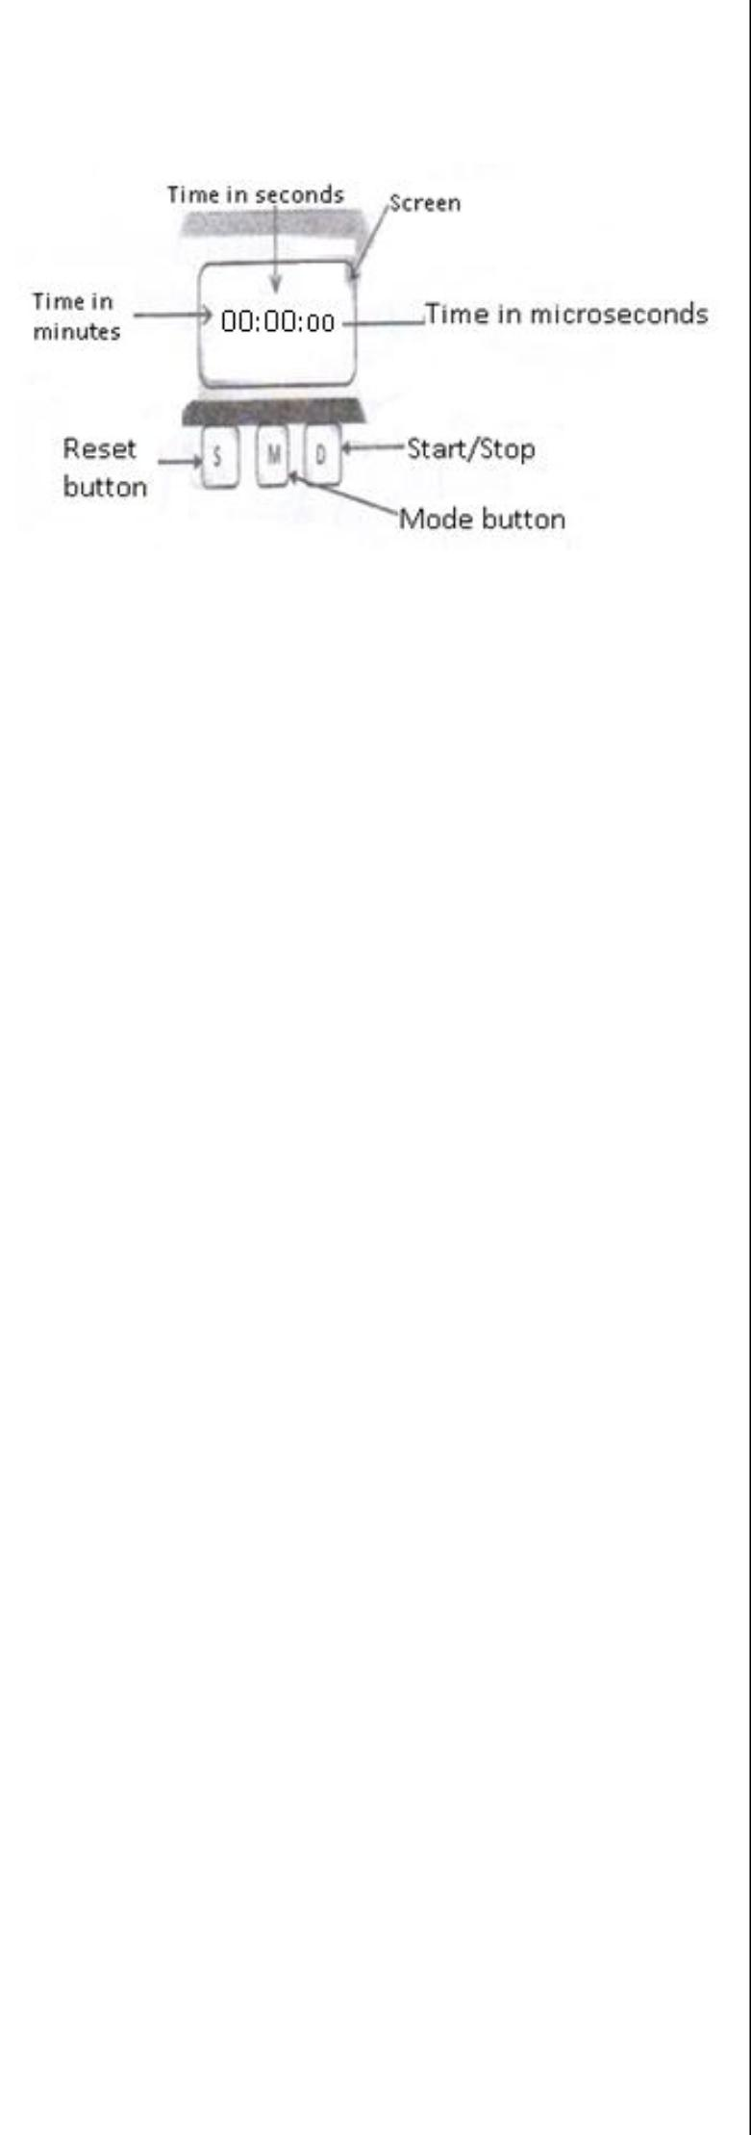

Before using the stopwatch, reset it such that its initial reading is zero as in the figure above.

**Examples**

Convert the time t, in the figures below to seconds

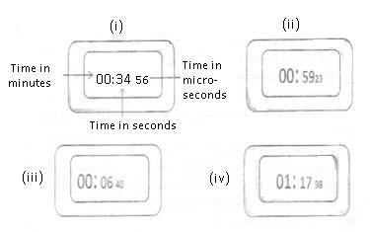

1. The reading is 34.56 seconds
2. The reading is 59.23 seconds
3. The reading is 6.40 seconds
4. The reading is 77.38 seconds i.e

1 × 60 + 17.38 = 77.38

**(ii) Stop Clock**

A reading on a stop clock is to one decimal place. i.e ; .0 or .5

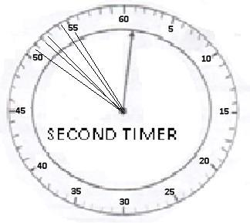

**In the figure, the reading of the stop clock is 60.5s or 0.5s (to 1 decimal place).**

In the 2nd figure above, the stop clock reading for the pointer in position A, B, C, D and E is as follows;

In position A, stop clock reading = 50.5s In position B, stop clock reading = 52.0s

In position C, stop clock reading = 53.0s not 52.8s In position D, stop clock reading = 54.0s not 54.4s In position E, stop clock reading = 55.0s

If the smallest division on the stop clock is **0.5s**, like the one above, then values of time are recorded to 1dp. However, if

the smallest division is 1s,of time are recorded to **0dp** (as whole numbers)

It is important to note that values recorded to a wrong number of decimal places are marked wrong even if they lie in the range for the correct values.



**Example 1:**

**In this experiment, you will investigate the relationship between the depression of a loaded beam and the distance between the supports*.***

**Procedure.**

1. Attach a pointer at the 50cm mark of the meter rule, use cello tape.
2. Place the meter rule so that it lies horizontally on the two knife edges provided.
3. Clamp a scale vertically and place it near the 50cm mark of the meter rule as shown in the figure below.

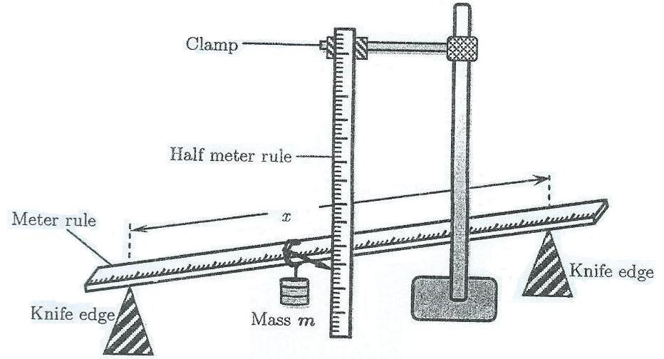

1. Adjust the knife-edges such that the distance *x* between them is equal to 90cm and they are equidistant from 50cm mark of the metre rule.
2. Read and record the position of the pointer on the scale.
3. Suspend a mass, m of 500g at the 50cm mark of the metre rule
4. Read and record the position of the pointer on scale. Hence find the depression, D, of the metre rule at its midpoint
5. Remove the mass from the metre rule.
6. Repeat the procedures (d) to (h) for values of *x* = 80cm, 70cm, 60cm, 50cm, and 40cm.
7. Enter your results in a suitable table including values of log10 D and log10
8. Plot a graph of log10 D ( along the vertical axis) against log10 D (along the horizontal axis)
9. Find the slop, N, of the graph.



**Apparatus:** *A meter ruler, Half meter rule, 2 knife edges, a 500g mass and retort stand with a clamp, pointer,**Cellotape.*

12

**SOLUTION**

**Recording single readings:**

e) Let Po be the initial position and pointer and P be the new position of the pointer Po= 80.0cm.Then D = P - Po

1. P = 84.8cm; D = P - Po
   * 84.8cm - 80.0cm
     + .

**Recording repeated readings:** j) **The table of results**

|  |  |  |  |  |
| --- | --- | --- | --- | --- |
| X(cm) | P(cm) | D(cm) | log10 X | log10 D |
| 90 | 84.8 | 4.8 | 1.954 | 0.681 |
| 80 | 82.8 | 2.8 | 1.903 | 0.447 |
| 70 | 81.7 | 1.7 | 1.845 | 0.230 |
| 60 | 81.2 | 1.2 | 1.778 | 0.079 |
| 50 | 80.6 | 0.6 | 1.699 | - 0.222 |
| 40 | 80.3 | 0.3 | 1.602 | - 0.523 |

**i) From the graph**,

 0.74  (0.50)

Slope; N

2.00 1.605

 0.3951.24

= .

**NOTE: Calculation for the scale should be done as side work and should not be included on the answer sheet because no marks are awarded for the working.**

**SIDE WORK**

|  |  |  |  |  |  |  |  |  |  |  |  |
| --- | --- | --- | --- | --- | --- | --- | --- | --- | --- | --- | --- |
| **Horizontal scale (log10x - axis)** | | | | | | **Vertical scale (log10D –axis)** | | | | | |
| 1 : |  | *RHA* |  | | | 1 : |  | *RVA* |  | | |
| 80 | |  |  |  | 100 | |  |  |  |
| 1 : | 1.954 1.602 | | | | | 1 : |  | 0.681  (0.523) | | | |
|  | 80 | | |  |  | 100 | | |  |
|  |  |  |  |
| 1 : |  | 0.352 | |  |  | 1 : | 1.204 | | |  |  |
|  | 80 |  |  |  |  | 100 | |  |  |
|  |  |  |  |  |  |  |
| 1: 0.044 | | | |  |  | 1: 0.01204 | | | | |  |
| 1: 005 | | |  |  |  | 1: 0.02 | | |  |  |  |
| **1 small square = 0.005** | | | | | | **1 small square = 0.02** | | | | | |
| **10 small squares = 0.05** | | | | | | **10 small squares = 0.2** | | | | | |
|  |  |  |  |  |  |  |  |  |  |  |  |



|  |  |
| --- | --- |
|  | 13 |

(k)

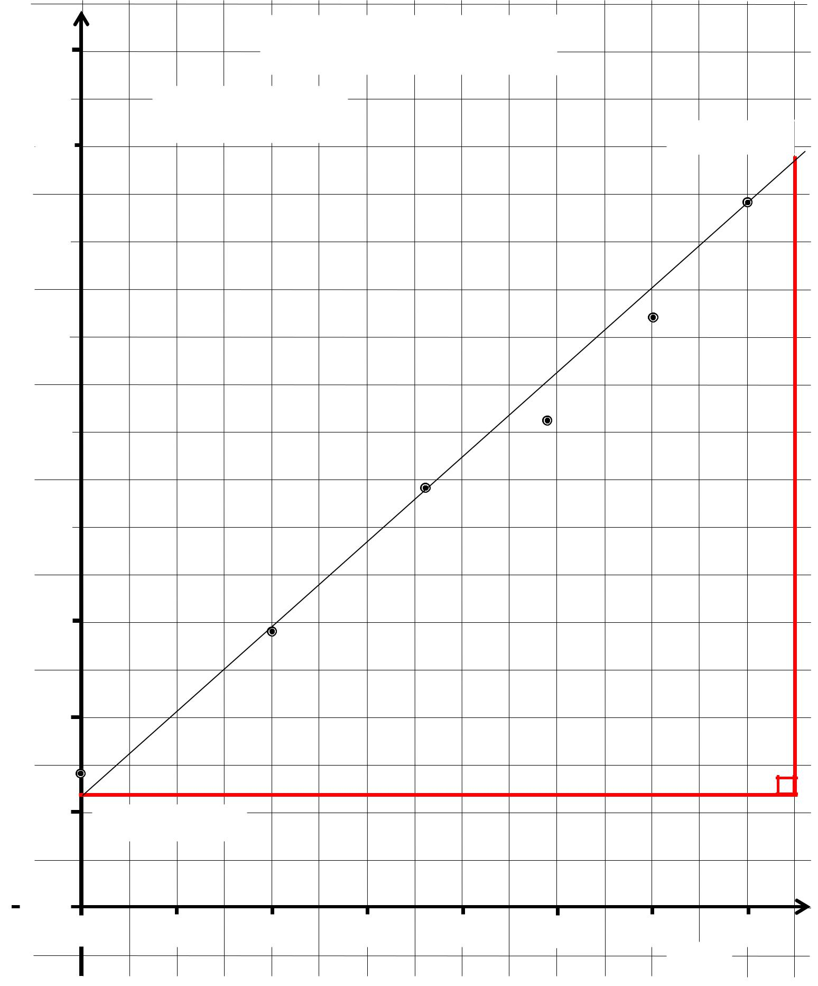

1.0

|  |  |
| --- | --- |
|  | Scale:V. A: 1: 0.02 |
|  |
| 0.8 | B(0.975,0.680) |
|  |



|  |  |
| --- | --- |
| −0.2 |  |
| −0.4 |  |
| −0.6 | A(1.600, − 0.560) |
|  |

|  |  |  |  |  |  |  |  |
| --- | --- | --- | --- | --- | --- | --- | --- |
| −0.8 |  |  |  |  |  |  |  |
| 1.60 | 1.65 | 1.70 | 1.75 | 1.80 | 1.85 | 1.90 | 1.95 |
|  |  |  |  |  |  |  |  |



|  |  |
| --- | --- |
|  | 14 |

**Example 2**

***In this experiment, you will be required to determine the acceleration due to gravity using a pendulum bob.***

**Apparatus**

Thread (130cm long), pendulum bob, retort stand with clamp and a stop clock

**Procedure**

1. Suspend the pendulum bob from a retort stand such that it is at a distance h = 0.10 m from the floor.
2. Adjust the length of the pendulum to 1.20 m.

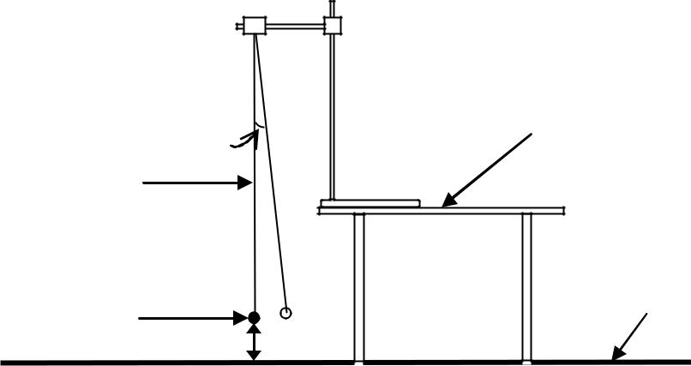

|  |  |
| --- | --- |
|  | Table Top |
|  | θ |
|  | Thread |
|  | Floor |
| **Fig. 2** | Pendulum bob |
| **h** = 0.10 |
|  |

1. Displace the bob through a small angle θ as shown in Fig. 2 above. Release it to oscillate in a vertical plane.
2. Determine the time for 20 oscillations.
3. Find the time, T, for one oscillation.

(f) Raise the pendulum bob (by reducing the length of the pendulum) by a distance h = 0.20, 0.30, 0.40, 0.50 and 0.60 m and in each case repeat procedures (c) to (e).

1. Record your results in a suitable table including values of T2.
2. Plot a graph of T2 against h.
3. Find the slope, **s**, of the graph.
4. Calculate the acceleration due to gravity, g, from the expression

− =



|  |  |
| --- | --- |
|  | 15 |

**SOLUTION**

**Recording single readings:**

Let t be the time for twenty oscillation

|  |  |  |  |  |  |  |  |  |  |
| --- | --- | --- | --- | --- | --- | --- | --- | --- | --- |
| a) | For h = 0.10 , |  |  |  |  |  |  |  |  |
| d) | t = 20T = 44.5s; = |  | = | 44.5 | | = 2.23 |  |  |  |
| 20 |  |  |  |  |  |
|  |  | 20 | | |  |  |  |  |
| **Recording repeated readings:** | | | | | |  |  |  |  |
|  | e) **The table of results** |  |  |  |  |  |  |  |  |
|  |  |  |  |  |  | h(m) | t(s) | T(s) | T2(s2) |
|  |  |  |  |  |  |  |  |  |  |
|  |  |  |  |  |  | 0.10 | 44.5 | 2.23 | 4.97 |
|  |  |  |  |  |  | 0.20 | 43.0 | 2.15 | 4.62 |
|  |  |  |  |  |  | 0.30 | 41.0 | 2.05 | 4.20 |
|  |  |  |  |  |  | 0.40 | 39.0 | 1.95 | 3.80 |
|  |  |  |  |  |  | 0.50 | 36.5 | 1.83 | 3.35 |
|  |  |  |  |  |  | 0.60 | 34.5 | 1.73 | 2.99 |

**i) From the graph**,



|  |  |  |  |  |  |  |  |  |  |
| --- | --- | --- | --- | --- | --- | --- | --- | --- | --- |
| g) Slope S from A to B; |  |  |  |  | h) From; | | |  |  |
| = | 5.10 − 2.90 | | |  | = | −4 2 | |  |  |
| 0.05 − 0.63 | | | |  |  |  |  |
|  | |  |  |
|  | 2.20 | |  |  |  | 22 | | 2 |  |
| = | |  |  |  |  |  |  |
|  |  | |  | −4 7 | |  |  |
| −0.58 | = |  |  |
| = −3.8 2 −1 | | | | | −3.8 | |  |  |
|  |  |  |
| = 10.4 −2 | | | | |
|  |  |  |  |  |
|  |  |  |  |  |  |  |  |  |  |

**NOTE: Calculation for the scale should be done as side work and should not be included on the answer sheet because no marks are awarded for the working.**

**SIDE WORK**

**Horizontal scale (h-axis)**

1 : *RHA*

80



1 : 0.6  0

80



1: 0.0075

1: 0.01

**1 small square = 0.01 m**

**10 small squares = 0.1 m**

**Vertical scale (T2 –axis)**

1 : *RVA*

100



1 : 4.97  2.99

100



1: 0.0198

1: 0.02

**1 small square = 0.02 s2**

**10 small squares = 0.2 s2**



|  |  |
| --- | --- |
|  | 16 |

**Example 3:**

***In this experiment, you will determine the refraction index ‘n’ of a glass block provided.***

**Procedure**

1. using the drawing pins provided, fix the plain white sheet of paper on a soft board
2. place the glass block in the middle of the sheet and using a pencil, mark the outline PQRS of the glass block
3. Remove the glass block. Draw perpendicular to PQ at point B, 1.5 cm from P

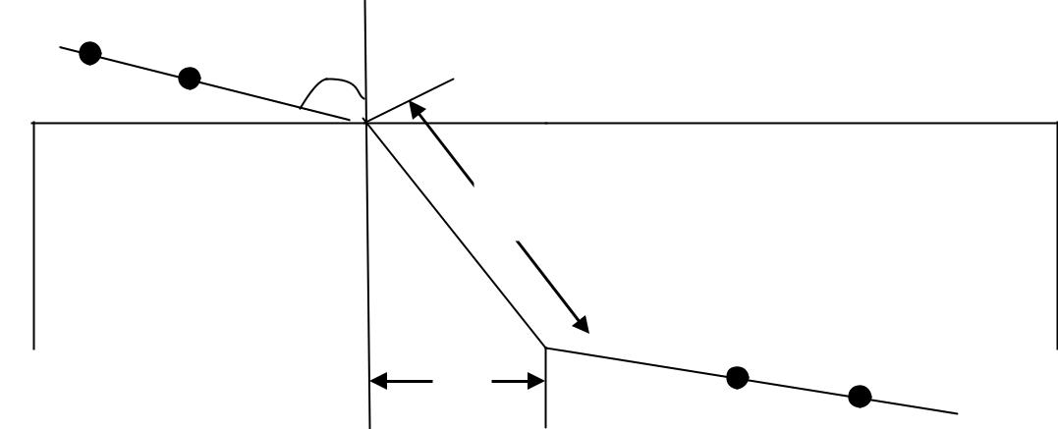

|  |  |
| --- | --- |
| A P1 | ***i*** |
|  | P2 |
| P | B |
| Q |
|  | ***x*** |

|  |  |  |  |  |  |  |
| --- | --- | --- | --- | --- | --- | --- |
|  | S |  |  |  |  | R |
|  |  | y | C |  |
|  |  |  |  |  |
|  |  |  |  | P3 | D P4 | |
|  |  |  |  |  |
| d) | Draw a line AB such that angle *i* = 100 | |  |  |  |  |
| e) | Replace the glass block on white sheet of paper on its outline. | | | |  |  |

1. Stick two pins P1and P2along AB and looking through the glass block the opposite face SR, stick other pins P3 and P4 in line with the images of P1 and P2. Remove the glass block
2. Join C and D. Measure and record the distance *x* and y
3. Repeat procedures (d) to (h) for values for *i* = 20, 30, 40, 50, 60, and 70 0
4. Enter your results in a suitable table including values of sin and
5. Plot a graph of sin against
6. Find the slope, ***n***, of your graph



**Apparatus**

Glass block, white sheet of paper,4 optical pins, 4 drawing pins, soft board and a complete geometry set



|  |  |
| --- | --- |
|  | 17 |

**SOLUTION**

**Recording single readings:**

h) For *i* **=**100 ,*x* = 1.0 cm, y = 6.6 cm

**Recording repeated readings:** j) **The table of results**

|  |  |  |  |  |  |  |  |
| --- | --- | --- | --- | --- | --- | --- | --- |
| 0 | ) | *x*(cm) | y(cm) |  |  | | sin |
| *i*( |  |  |  |
|  |  |  |  |  |  | |  |
| 10 | | 1.0 | 6.6 | 0.15 | | | 0.174 |
| 20 | | 1.5 | 6.7 | 0.22 | | | 0.342 |
| 30 | | 2.4 | 7.0 | 0.34 | | | 0.500 |
| 40 | | 3.2 | 7.4 | 0.43 | | | 0.643 |
| 50 | | 3.8 | 7.6 | 0.50 | | | 0.766 |
| 60 | | 4.6 | 8.0 | 0.58 | | | 0.866 |

1. **From the graph**,
   1. − 0.10 Slope, n = 0.70 − 0.04

0.90 Slope, n = 0.66

= 1.4

**NOTE: Calculation for the scale should be done as side work and should not be included on the answer sheet because no marks are awarded for the working.**

|  |  |  |  |  |  |  |  |  |  |  |  |  |  |
| --- | --- | --- | --- | --- | --- | --- | --- | --- | --- | --- | --- | --- | --- |
|  |  |  |  |  |  |  |  | **SIDE WORK** | | | | | |
|  |  |  |  |  |  |  | |  |  |  |  |  |  |
|  |  |  |  |  |  |  | |  | **Vertical scale ( sin*i* –axis)** | | | | |
|  |  |  |  |  |  |  |  |  |
| **Horizontal scale ( - axis)** | | | | | | | |
|  |  |  | *RVA* |  | |
|  |  | *RHA* | | |  |  |  |  | 1 : |  |
| 1 : |  |  |  |  |  | 100 | |  |  |
|  | 80 |  |  |  |  |  |  |  |  |  |
|  |  |  |  |  |  |  |  |  |  |  |
|  |  |  |  |  |  |  |  |  |  | 0.866  0.174 | |  |
|  |  | 0.58  0.15 | | |  |  |  |  | 1 : | |  |
| 1 : |  |  |  |  |  | |
|  |  |  |  |  |  |  |  |  | 100 | | |  |
|  | 80 | |  |  |  |  |  |  |  |
|  |  |  |  |  |  |  |  |  |
|  |  |  |  |  |  |  | 1: 0.00692 | | | |  |
|  |  | 1: 0.005375 | | |  |  |  |  |  |
|  |  |  |  |  |  | 1: 0.01 | | |  |  |
|  |  | 1: 0.01 | |  |  |  |  |  |  |  |
|  |  |  |  |  |  |  | **1 small square = 0.01** | | | | |
| **1 small square** | | | | | **= 0.01** | | |  |
|  | **10 small squares = 0.1** | | | | |
| **10 small squares = 0.1** | | | | | | | |  |
|  |  |  |  |  |  |
|  |  |  |  |  |  |  |  |  |  |  |  |  |  |



|  |  |
| --- | --- |
|  | 18 |

|  |  |
| --- | --- |
| (j) | A Graph of Sin *i* against *x* |
| **y** |
| Sin *i* |  |
| **Scale: V.A: 1 : 0.01** | |
|  | **H.A: 1 : 0.01** |
|  | **B(0.70, 1.03)** |
| **A(0.07, 0.1)** |  |
|  | *X* |
|  | Y |
|  | 19 |

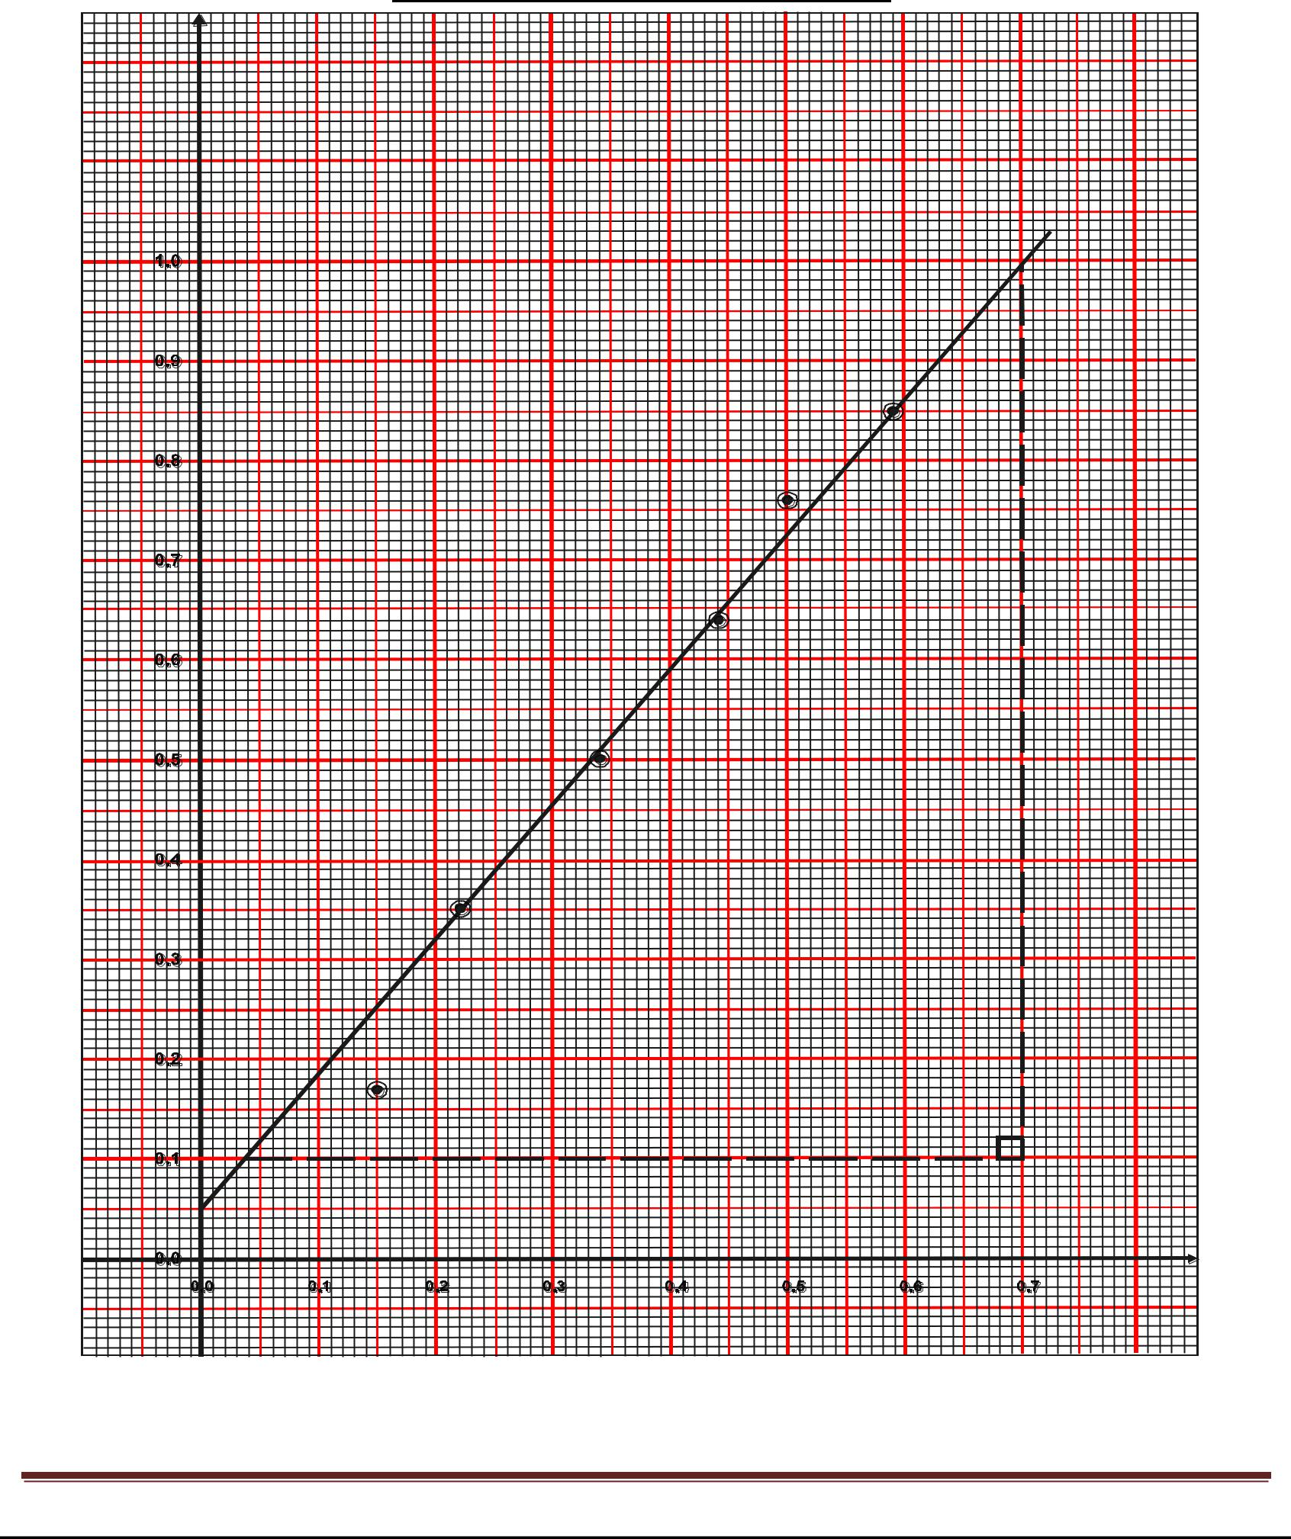

**SAMPLE MARKING GUIDE FOR THE ABOVE QUESTION**

|  |  |  |  |  |
| --- | --- | --- | --- | --- |
| **CODE** | **DESCRIPTION** | |  | **MARKS** |
|  |  |  |  |  |
| D1 | Tracing the outline PQRS of the glass block |  |  | = ½mrk |
|  |  |  |  |  |
| D2 | Drawing a perpendicular at point B1 =1.5cm from P |  |  | = ½mrk |
|  |  | | |  |
| D3 | Drawing a line AB such that angle ***i***=10o and sticking pins P1 and P2 along AB | | | = ½mrk |
|  |  | |  |  |
| D4 | Sticking pins P3 and P4 in line with the images of P1 and P2 | |  | = ½mrk |
|  |  | | |  |
| D5 | Drawing a line through pin marks P3 and P4 to meet SR at C and joining C and B | | | = ½mrks |
|  |  |  | |  |
|  |  | **Sub-total** | | **2½marks** |
|  |  | |  |  |
| R1 | Recording the values of x to 1dp when***i***=10o and unit: range | | (0.8 – 4.8) (cm) value = ½ | =1mrks |
|  | ;unit: (cm) = ½ mrk |  |  |  |
|  |  | |  |  |
| R2 | Recording the values of y to 1dp when*i* = 10o and unit range | | (6.4 – 8.6) (cm) value = ½ | =1mrks |
|  | mrk; unit (cm) = ½ mrk |  |  |  |
|  |  | | |  |
| T1 | Design of the table of results with 5 columns, *i*– column labeled with unit *i*(o) and all values | | | =½mrk |
|  | entered |  |  |  |
|  |  | |  |  |
| T2 | Label of the rest of the values of x increasing to 1dp (1.3 – 1.7), | | (2.2-2.6), (3.0-3.4), (3.6- | =2½mrks |
|  | 4.0) and ( 4.4 - 4.8) (cm) | (@½ mrk) |  |  |
|  |  | | |  |
| T3 | Recording 6 values of sini and x/y correctly calculated (any 3 correct) (@½ mrk) | | | =3mrks |
|  |  |  | |  |
|  |  | **Sub-total** | | **08 marks** |
|  |  |  |  |  |
| G1 | Title of the graph; A graph of sini against x/y |  |  | =½mrk |
|  |  |  |  |  |
| G2 | The label of the axes with units; sini and x/y |  | (@½ mrk) | =1mrk |
|  |  |  |  |  |
| G3 | Suitable and convenient scales for the axes | covering at | least 50% of graph paper | =1mrk |
|  | (@½ mrk) |  |  |  |
|  |  |  |  |  |
| G4 | 6 correctly plotted points |  | (@½ mrk) | =3 mrks |
|  |  |  |  |  |
| G5 | The best straight line to fit the plotted points |  |  | =½ mrk |
|  |  | | |  |
| G6 | The method of finding the slope. Big triangle covering all plotted points | | | =½ mrk |
|  |  |  | |  |
|  |  | **Sub-total** | | **6½ marks** |
|  |  |  |  |  |
| C1 | Calculation of the slope, n |  |  | =1½mrk |
|  |  |  |  |  |
| C2 | Correct substitution |  |  | =½ mrk |
|  |  |  |  |  |
| C3 | Arithmetic |  |  | =½ mrk |
|  |  |  |  |  |
| C4 | Accuracy |  |  | =½ mrk |
|  |  |  | |  |
|  |  | **Sub-total** | | **03marks** |
|  |  |  |  |  |
|  | **TOTAL** |  |  | **20 marks** |
|  |  |  |  |  |



|  |  |
| --- | --- |
|  | 20 |

* 1. MECHANICS EXPERIMENTS

1. **Experiment 01**

**In this experiment, you will determine the mass, m of a metre rule**.

1. Balance the metre rule provided on a knife-edge with the graduated side facing upwards.
2. Note the balance point P and record its distance, *l*o, from end B.
3. Place a mass *m* of 10 g on top of the metre rule at the 10 cm mark and balance the arrangement as shown in Fig. 1 below.

|  |  |  |  |  |  |  |  |  |  |  |  |  |  |
| --- | --- | --- | --- | --- | --- | --- | --- | --- | --- | --- | --- | --- | --- |
|  |  |  | m | |  |  |  |  | *l*o |  |  |  |  |
| Metre rule | A | |  |  |  |  |  | P |  |  |  |  | B |
|  |  |  |  |  |  |  |  |  |  |  |  |
| **Fig. 1** |  | 10 cm |  |  |  | *l*1 |  | Knife edge | *l*2 |  |  |  |  |
|  |  |  |  |  |  |  |  |  |
|  |  |  |  |  |  |  |  |  |  |
|  |  |  |  |  |  |  |  |  |  |  |  |  |
| (d) Read and record the distances *l*1 and *l*2. | | | | | | |  |  |  |  |  |  |  |
| (e) Repeat the procedures (c) and (d) for values of *m* = 20, 30, 40, 50 and 60 g. | | | | | | | | | | |  |  |  |
| (f) Record your results in a suitable table including the values of (*l*2 – *l*o) and | | | | | | | | | | 2 | − o | . |  |
|  | 1 |  |
|  |  |  |  |  |  |  |  |  |  |  |  |  |
|  |  |  |  | − |  |  |  |  |  |  |  |  |  |
| (g) Plot a graph of **m** against | | |  |  | . |  |  |  |  |  |  |  |
|  |  |  |  |  |  |  |  |  |  |
|  |  |  |  |  |  |  |  |  |  |  |  |  |
|  |  |  |  |  |  |  |  |  |  |  |  |  |  |

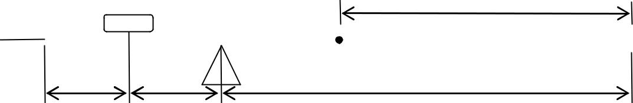

(h) Find the slope, m of your graph.



**Apparatus:** *Knife edge; Metre rule; One mass of 10 g, Two masses of 20 g, One mass of 50 g [or you**may use six 10 g masses]*



|  |  |
| --- | --- |
|  | 21 |

**1.02 Experiment 02**

**In this experiment, you will determine the mass, m of a metre rule provided**

1. Suspend the metre rule provided from a clamp using a piece of thread.
2. Adjust the metre rule until it balances horizontally.
3. Read and record the balance point C.
4. Place the thread at a distance of *y* = 10 cm from C as shown in Fig.2 below.

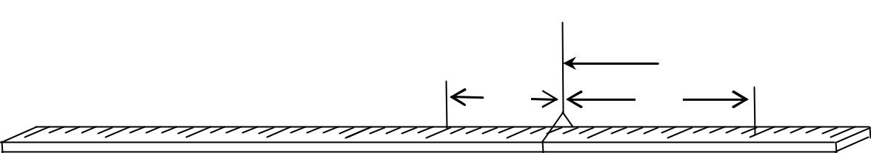

Stand support



|  |  |
| --- | --- |
|  | Thread |
| *y* | *x* |
| C |  |

|  |  |  |
| --- | --- | --- |
| **Fig. 2** |  |  |
| **m** | |
|  |  |  |

1. Starting with m = 40 g adjust the position of the mass m until the metre rule balances horizontally again.
2. Measure and record the distance *x*.
3. Repeat procedures (d) to (e) for values of m = 50, 60, 70, 80 and 100 g.
4. Record your results in a suitable table including values of 1*x* .
5. Plot a graph of m against 1*x* .
6. Find the slope, S.
7. Calculate the mass of the metre rule from the expression;

**M = 0.10S.**

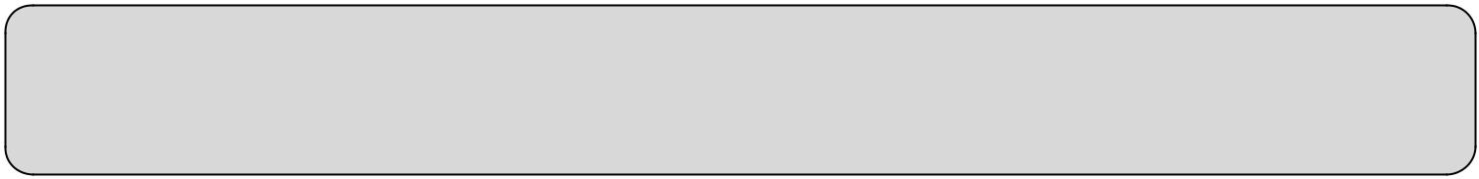

**Apparatus**

*One 10 g mass, two 20 g masses, one 50g mass and one 100g mass (slotted on a mass hanger); a metre rule; two pieces of thread, 30 cm each, Retort stand with clamp*



|  |  |
| --- | --- |
|  | 22 |

**1.03 Experiment 03**

**In this experiment you will determine the density,** **, of the rubber bug provided.**

(a) Record the mass, M of the metre rule provided.

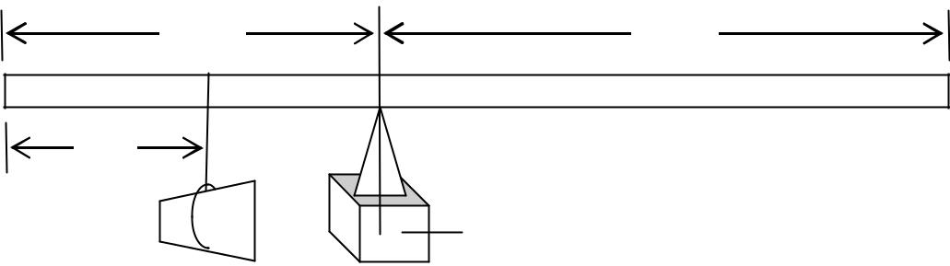

|  |  |  |
| --- | --- | --- |
| d1 |  | d2 |
| d |  |  |
| **Fig. 3** | W | Wooden block |
|  |
|  |  |

1. Suspend the rubber bung, W, at a distance d = 5 cm from the zero end of the metre rule.
2. Balance the metre rule with its graduated face upwards on the knife edge as shown in Fig.3 above.
3. Measure and record the distances, d1 and d2, of the knife edge from the zero and 100 cm marks of the metre rule respectively.
4. Repeat procedures, (b) to (d) for values of d equal to 10, 15, 20, 25 and 30 cm.
5. Tabulate your results, including values of (d2 – d1) and (d1 – d).
6. Plot a graph of (d2 – d1) against (d1 – d).
7. Find the slope, S, of your graph.
8. Determine the density, , of rubber from the expression;
   * **= 0.5 S.**



**Apparatus**:*Rubber bung; a metre rule labelled with its mass M; knife edge; wooden block, 20 cm × 15**cm × 15 cm and a piece of thread, 20 cm.*



|  |  |
| --- | --- |
|  | 23 |

**1.04 Experiment 04**

**In this experiment you will determine the density of water.**

(a) Record the radius, r, of the small beaker (or can) provided

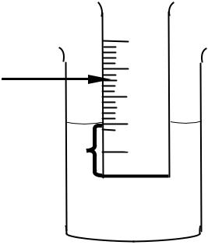

Small beaker



Scale

**h**  Bottle top Sand



**Fig. 4** Water  Large beaker



1. Place the small beaker (or can) into the large beaker containing water.
2. Add small quantities of sand gradually into the small beaker until the beaker floats upright in the water as shown in Fig. 4 above. Make sure the small beaker does not touch the sides of the large beaker.
3. Place three bottle tops into the small beaker.
4. Read and record the depth, h, by which the small beaker sinks.
5. Repeat procedures (d) and (e) for 6, 9, 12 and 15 bottle tops.
6. Record your results in a suitable table.
7. Plot a graph of number of bottle tops against h.
8. Find the slope, S, of the graph.
9. Calculate the density of water, , from the expression
   1. **S =** **r2.**

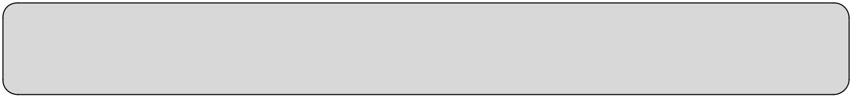

**Apparatus**

*A small beaker with its radius****r*** *indicated and linear scale using a graph paper strip attached; a large beaker; 15 soda bottle tops; small amount of sand and water.*



**1.05 Experiment 05**

**In this experiment, you will determine the relative density of a liquid, provided.**

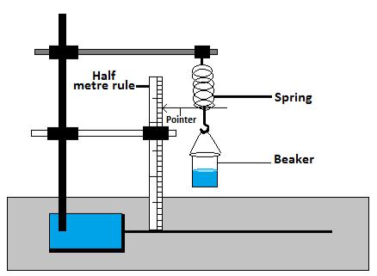

Fig.5

**Procedure**

1. Clamp the spring provided vertically and suspend the empty beaker as show in Fig.5
2. Record the initial position of the pointer on the metre rule.

c) Pour volume, **V= 50 cm3** of water into a beaker and record the new position of the pointer.

1. Find the extension, ***x*** produced.
2. Repeat the procedures (c) to (d) for **V= 100, 150, 200 and 250 cm3**.
3. Pour out water and dry the beaker.
4. Repeat the procedures (a) to (e) using the liquid and find its extension, ***y*** produced.
5. Record results in a suitable table.
6. Plot a graph of ***y*** against ***x***
7. Determine the slope, ***S*** of the graph.



**Apparatus**:

*Liquid, (paraffin or Cooking oil or Petrol), water, Retort stand with 2 clamps, Metre rule, pointer, spiral spring, thread, measuring cylinder and a beaker.*



|  |  |
| --- | --- |
|  | 25 |

**1.06 Experiment 06**

**In this experiment, you will determine the acceleration due to gravity, g using a spiral spring.**

**Apparatus**:

A retort stand with 2 clamp, 5 masses of 50 grams on a hanger, 1 spring, stop watch or clock, metre rule, pointer.

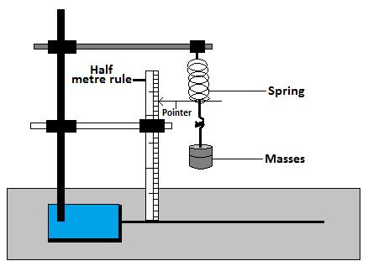

**Fig. 6**

**PART ONE**

1. Suspend the spiral spring provided from a clamp as shown in Fig. 6.
2. Read and record the position of the pointer on the metrerule.
3. Suspend the mass, **M** = 50 g from the free end of the spiral spring.

d) Read and record the new position of the pointer, find the extension, ***e*** of the spring.

1. Repeat the procedure in (c) and (d) for values of **M** = 100, 150, 200, and 250 g.
2. Tabulate your results in a suitable table.
3. Plot a graph of ***e*** against **M**.
4. Find the slope, **S1** of the graph.

**PART TWO**

1. Remove the metre rule.
2. Displace the mass, **M** =**50 g** suspended from the spring through a small vertical distance and release it.
3. Determine the time, t for 20 oscillations.
4. Find the periodic time, T for an oscillation
5. Repeat the procedures (b) to (d) for values of **M** =**100,150, 200, and 250 g**.
6. Enter your results in a suitable table including values of T and T2.
7. Plot a graph of T2 against M
8. Determine the slope, **S2** of the graph.
9. Find the value of acceleration due to gravity, .From;

=



|  |  |
| --- | --- |
|  | 26 |

**1.07 Experiment 07**

**In this experiment, you will determine the acceleration due to gravity.**

(a) Suspend the pendulum bob from a retort stand as shown in Fig. 10 below.

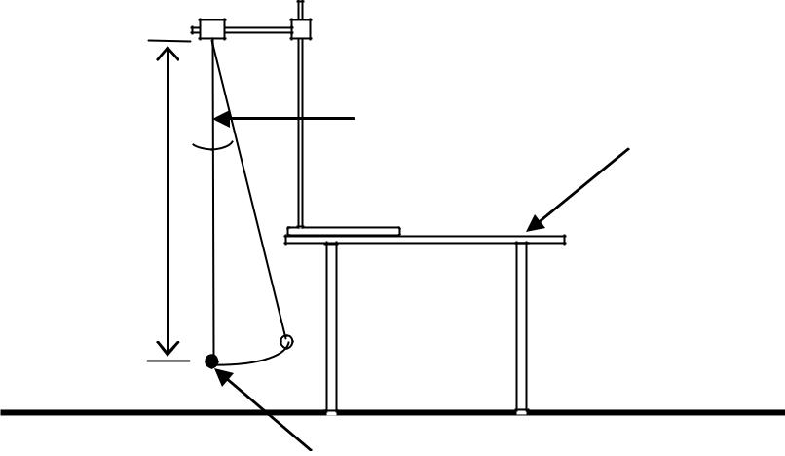

|  |  |
| --- | --- |
| Thread | Bench Top |
|  |

θ

***l***

|  |  |
| --- | --- |
| **Fig. 7** | Pendulum bob |
|  |

1. Adjust the length of the pendulum, ***l****,* so that it is equal to 1.00m.
2. Displace the bob through a small angle θ as shown in Fig. 7 above. Release it to oscillate in a vertical plane.
3. Determine the time, t, for 20 oscillations.
4. Find the time, T, for one oscillation.
5. Repeat procedures (b) to (e) for values of ***l =*** 0.90, 0.80, 0.70, 0.60, 0.50 and 0.40 m.
6. Record your results in a suitable table including values of T 2.
7. Plot a graph of T2 against ***l****.*
8. Find the slope, s, of the graph.
9. Calculate the acceleration due to gravity, g, from the expression;

= **.**



**Apparatus**

*A pendulum bob, a string about 120 cm, a stop clock, metre rule and retort stand with a clamp.*



|  |  |
| --- | --- |
|  | 27 |

**1.08 Experiment 8**

**In this experiment you are required to determine the acceleration due to gravity, g.**

(a) Clamp the spring provided with a pointer attached and a metre rule as shown in Fig. 8 below.

Clamp

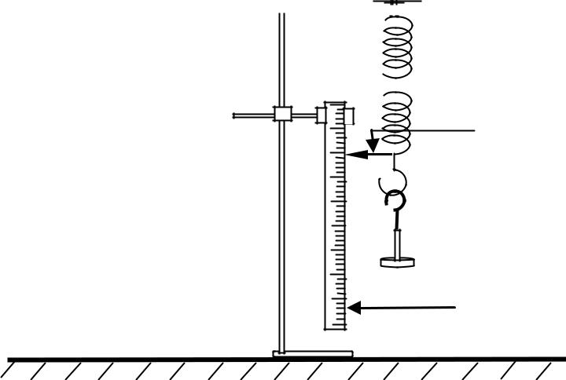

Spring



Pointer

Retort stand



Metre rule

**Fig. 8**

1. Read and record the initial position Po of the pointer on the metre rule.
2. Attach a mass, m, equal to 0.100 kg on the spring and record the new position P1 of the pointer. Hence, find the extension, *x*, in metres.
3. Pull the mass downwards through a small distance and release it.
4. Measure and record the time for 20 oscillations.
5. Calculate the time, T, for one oscillation.
6. Repeat the procedures (d) to (f) for values of m equal to 0.200, 0.300, 0.400 and 0.500 kg
7. Record your results in a suitable table including values of T 2.
8. Plot a graph of T 2 against m.
9. Find the slope, *s* of the graph.
10. Calculate *g* from the expression;

*g*  40*π* 2 *x* *s*

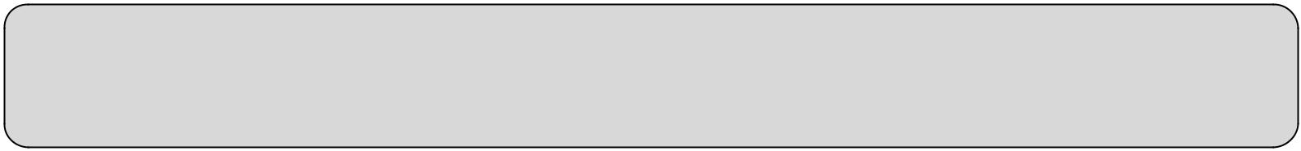

**Apparatus**

*A spring with a pointer, five 100 g masses on a mass hanger, stop clock, and a metre rule (or half metre rule); and retort stand with a clamp.*



|  |  |
| --- | --- |
|  | 28 |

**1.09 Experiment 9**

**In this experiment, you will determine the relative density,** **of the material of solid X provided.**

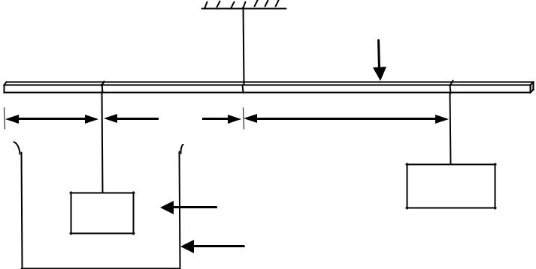

|  |  |  |  |  |
| --- | --- | --- | --- | --- |
|  |  |  |  | Metre rule |
|  | A |  |  | B |
|  |  | **z** | P | Q |
|  | ***d*** |  | ***y*** |
|  |  |  |
|  |  |  | Water | 100 g |
|  | X |  |  |
| **Fig. 9** |  |  |  |
|  |  | Beaker |  |
|  |  |  |  |

1. Record the mass, *M*, of the solid X provided.
2. Suspend a metre rule from a clamp using a piece of thread and adjust it until it balances horizontally.
3. Read and record the distance of the balance point, P, of the rule from end A.
4. Suspend the solid, X at a distance d = 10 cm from end A of the metre rule and immerse it completely in water in the beaker.
5. Suspend a 100 g mass from a point, Q, between P and B and then adjust the position of Q until the metre rule balances horizontally, with X completely immersed and not touching the beaker as shown in Fig. 9 above.
6. Measure and record distances z and y.
7. Repeat procedure (d) to (i) for values of d = 15, 20, 25, 30 and 35 cm.
8. Enter your results in a suitable table.
9. Plot a graph of z against y.
10. Find the slope, s, of the graph.
11. Calculate the relative density,, of the material from the expression;

|  |  |
| --- | --- |
| ❒ = | M |
|  |
| M 100S |
|  |



**Apparatus:** *Plastic Beaker, Metre rule, 100 g mass, 3 pieces of thread of 30 cm each, solid x, with its**mass M indicated, water.*



|  |  |
| --- | --- |
|  | 29 |

**1.10 Experiment 10**

**In this experiment, you will determine Young’s modulus for wood.**

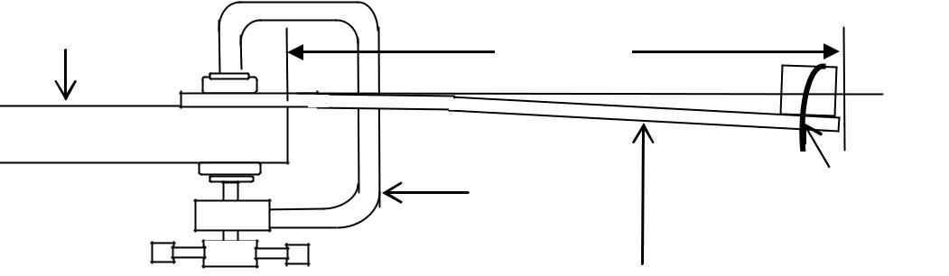

|  |  |
| --- | --- |
| Desk-top |  |
| 80 cm | M |
|  |
| G – Clamp | Rubber band |
|  |

|  |  |
| --- | --- |
| **Fig. 10** | Metre ruler |
|  |

1. Record the thickness, d, of the metre rule.
2. Clamp the metre rule provided with the graduated face upwards such that the free length equals 80 cm as shown in Fig. 10 above.
3. Attach a mass, M equal to 0.05 kg at the end of the metre rule using a rubber band or thread.
4. Depress the mass through a small vertical distance and release it to oscillate.
5. Measure and record the time for 20 oscillations. Find the period, T.
6. Repeat the procedures (c) to (e) for M equal to 0.10, 0.15, 0.20, 0.25 and 0.30 kg
7. Record your results in a suitable table including values of T2.
8. Plot a graph of T2 (along the vertical axis) against M (along the horizontal axis).
9. Find the slope, *S*, of the graph.
10. Calculate Young’s modulus, Y, for wood from;

=



**Apparatus:** *G-Clamp; Wooden metre rule with its thickness, d indicated; one 50 g mass; Three 100 g**masses; Rubber band; Stop clock*



|  |  |
| --- | --- |
|  | 30 |

**1.11 Experiment 11**

**In this experiment, you will determine the spring constant of the spiral spring provided.**

1. Clamp the spring using the two pieces of wood provided and make sure that the spring is vertical as shown in Fig. 11(a) below.
2. Attach a pointer to the free end of the spring. Read and record the pointer position xo on a vertical metre rule.

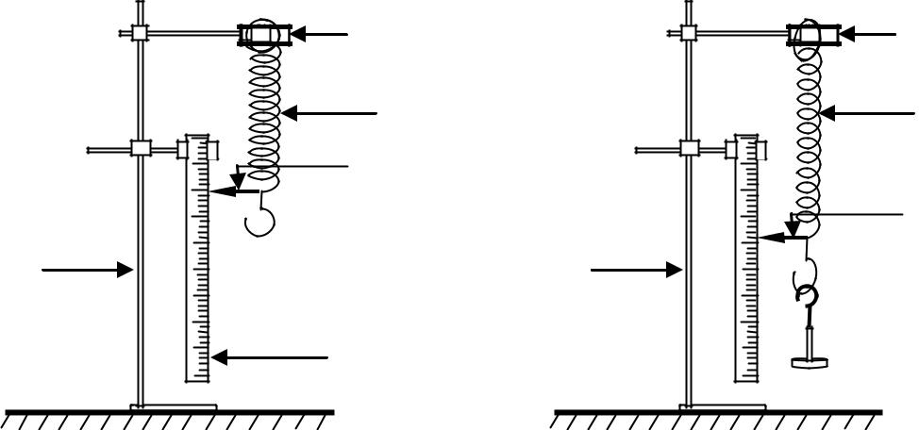

|  |  |  |
| --- | --- | --- |
|  | Clamp | Clamp |
|  | Spring | Spring |
|  | Pointer |  |
|  |  | Pointer |
| Retort stand | Retort stand |  |
|  | Metre rule | **m** |
|  | **Fig.11 (a)** | **Fig.11 (b)** |

1. Suspend a mass, m = 0.100 kg from the lower end of the spring as shown in Fig.11 (b) above.
2. Read and record the new position of the pointer ***x*1**.
3. Repeat procedures (c) and (d) above for the values of m = 0.200, 0.300, 0.400, 0.500 and 0.600 kg.
4. Record your results in a suitable table including values of the extension, **e** in metres.
5. Plot a graph of e against m.
6. Find the slope, S, of the graph.

(i) Determine the elastic constant, k from k = *S*1



**Apparatus**

*A spring with a pointer; Six 100 g masses on a mass hanger; and a metre rule; and retort stand with a clamp.*



|  |  |
| --- | --- |
|  | 31 |

2.00 LIGHT EXPERIMENTS

**Glass blocks:** Glass blocks of any dimensions can be used. However, that of100mm × 60mm × 18mmispreferred.

**Glass Prisms:** Equilateral triangular prisms should be used unless stated otherwise.

**Mirrors and Lenses:** The suitable focal length of a mirror or lens should be smaller than the smallest value ofthe object distance.

Eg in experiment 22, the smallest object distance **d=15cm**, the suitable mirror is that of **f=10, or 5 cm**. In experiment 32, the smallest object distance **u = 30 cm**, the suitable lens is that of **f= 25, 20, 15, 10 or 5 cm**.

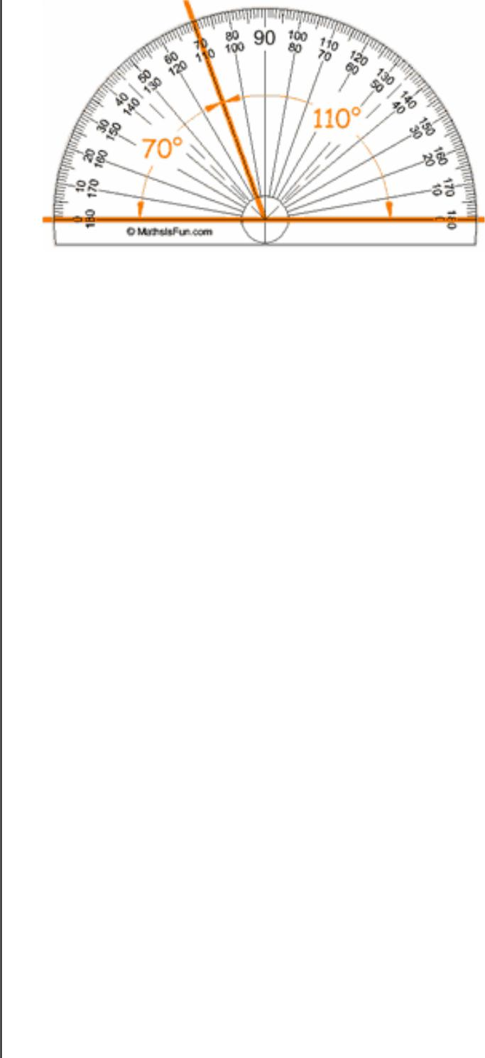

* 1. **PROTRACTOR**
* A Protractor measures angles in degrees (*°*)
* A small division on a protractor is an angle of 1*°* (0 d.p)
* Since 1*°* has no decimal place angles measured with a protractor should be recorded without a decimal place e.g. 19*°*, 50*°*, 87*°* 32*°*.

A protractor measures angles between two intersecting lines in degrees (°) to zero decimal places. All values of angles obtained using a protractor must be recorded to zero decimal places (as whole numbers) e.g. 10°, 9°, 23°, 64° etc.

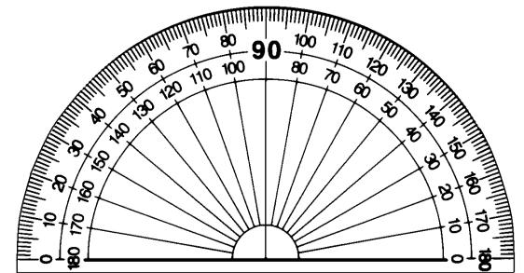

**How to Measure an Angle with a Protractor?**

Angles are measured in degrees.

**Step 1**. The zero line of the protractor needs to be lined upwith one side of the angle.

**Step 2.** You read the set of numbers from your zero line to theline where the angle stops..

**How to draw angles using a protractor**

**Step 1**. To draw an angle of 50 degrees first draw a linesegment that is to be the one side of the angle.

**Step 2**. Then put the protractor so that its zero line matcheswith your line segment and that the vertex is in place.

**Step 3**. Now put a mark at the 50 degree point.

**Step 4**. Then take the protractor off and draw a line throughyour mark.

Protractors usually have two sets of numbers going in opposite directions. Be careful which one you use!

When in doubt think "should this angle be bigger or smaller than 90° "

**RULERS (eg. Metre – Rule)**

The different types of rulers are 15cm ruler, 30 cm rulers, half-metre rule and a metre-rule. They are all used in the same way.

* The metre rule measures lengths in Centimetres (cm)
* 1 Small division on the scale is equal to a length of 0.1cm
* This Value has one decimal place and it means that all measurements with a metre rule should be recorded to 1 decimal place in cm
* In metres 0.1cm = 0.001m, so when measurements on a metre rule are converted into metres, they should be recorded to 3 decimal places following the fact that ; 1 Small division= 0.1cm = 0.001m(3d.p)

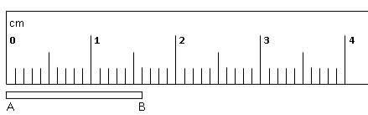

From; 0 to 1, 1 to 2, 2 to 3, etc, there are 10 equal divisions.

=

|  |  |  |  |
| --- | --- | --- | --- |
| 1 division = | 1 cm | | = 0.1 cm |
|  |  |
| 10 |  |

**Therefore any reading from rulers is accurate 1 decimal place. Hence, such readings should be recorded to 1dp.**

|  |  |
| --- | --- |
| Length AB | = 1.0 cm + 6 × 0.1 cm |
| Length AB | = 1.6 cm |
| Or Length AB | = 16 × 0.1 = 1.6 cm |



|  |  |
| --- | --- |
|  | 32 |

**2.01: Experiment 12:**

***In this experiment, you will investigate the relationship between the number of images n formed by two plane mirrors inclined to each other and the angle between the mirrors.***

1. Draw two lines such that they make an angle **θ = 900** at the point of intersection as shown in the figure 12 below.

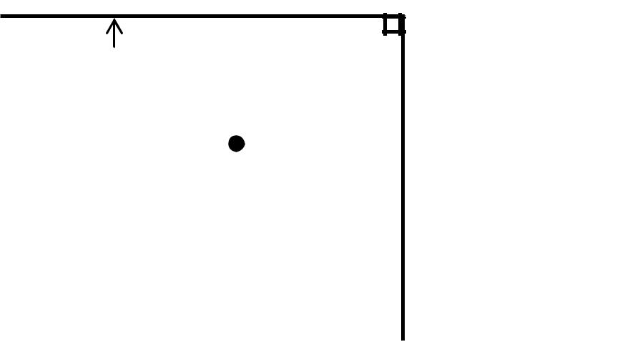

Plane mirror **B**

Optical pin

**Fig. 12**

Plane mirror **A**



1. Place mirrors **A** and **B** as shown above on the lines drawn
2. Place an optical pin at a distance of about 6cm in front of the point of intersection of the two mirrors such that it is equidistant from the two mirrors.
3. Count and record the number of images, **n** observed. (place the eye at a distance of more than half a metre away from the mirrors)
4. Keeping mirror **A** on the line, repeat procedures **(c)** and **(d)** adjusting the position of **B** such that it makes the angle **θ =700, 600, 400**and **300**.
5. Enter your results in a suitable table including values of
6. Plot a graph of **n** against
7. Find the intercept, **C**, on the **n**-axis
8. Find the slope of the graph.

**Note: *Hand in your working sheet.***



***Apparatus***: 2 mounted plane mirrors, 4 drawing pins, 1 optical pin, and Complete Mathematical set.



|  |  |
| --- | --- |
|  | 33 |

**2.02 Experiment 13**

***In this experiment, you will be required to verify that the angle of incidence is equal to the angle of reflection.***

1. Fix a white sheet of paper, provided on the soft board and place the plane mirror vertically on it.
2. Put the plane mirror on the white sheet of paper and trace the mirror line with a sharp pointed pencil as shown in Fig.13 below.

**Fig. 13**

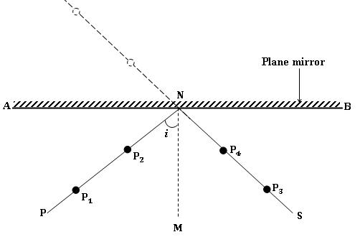

1. Remove the mirror from the paper. Label the traced line as AB.
2. Draw a normal MN bisecting the mirror line AB
3. Draw a line PN at angle *i* = 10o to MN.
4. Fix pins P1 and P2 along the line PN.
5. Place the mirror back on the paper so that it’s reflecting surface coincides exactly with the mirror lining AB you have drawn.
6. View the images of P1 and P2 in the mirror.
7. Fix pins P3 and P4 such that they are in line with images of P1 and P2.
8. Remove the pins P1, P2, P3 and P4 and the mirror from the white sheet of paper.
9. Draw a line NS passing through the marks of pins P3 and P4.
10. Measure and record the angle ***r***, between MN and NS.
11. Repeat procedures (e) to (l) for angles *i* = 20o, 30o, 40o, 50o, 60o and 70o.
12. Record your values of ***i*** and ***r*** in a suitable table.
13. Draw a graph of ***i*** against ***r*** and find its slope.



|  |  |
| --- | --- |
|  | 34 |

**2.03 Experiment 14**

***In this experiment, you will verify that the angle of incidence, reflected ray and the normal line at the point of incidence, all lie in the same plane.***

**Procedures**

1. Fix the plain sheet of paper on the soft board provided
2. Draw a line RS in the middle of the white sheet of paper provided.
3. Draw a normal ANM on RS as shown in Fig. 14.

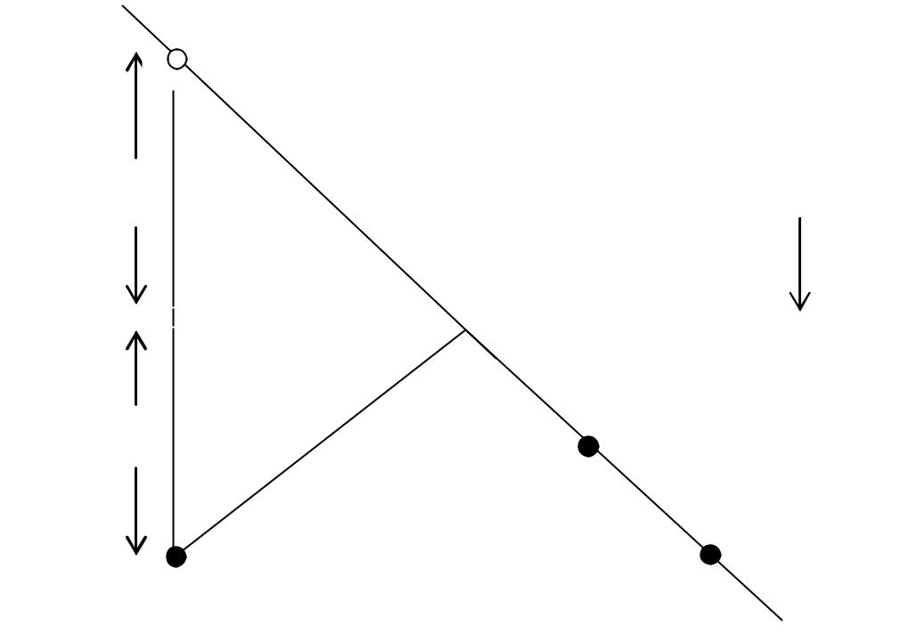

|  |  |  |  |
| --- | --- | --- | --- |
|  | *y* | **Plane mirror** | |
|  |  |
|  |  |  | |
|  |  |  |
| *x* |  |
|  |  | |
|  |  |  | |

|  |  |  |
| --- | --- | --- |
| **Fig. 14** |  |  |
|  |  |  |
|  |  |

d) Measure the distance NM, x = 1.5cm and fix a pin at M

e) Place the mirror along the mirror line RS as shown in Fig. 14 above

f) View the image of the pin at M from the right hand side of the normal ANM and fix pin P1, and P2 such that they are in the line with the image of the pin at M

g) Remove the pins P1 and P2 and the mirror from the white sheet of paper

h) Draw a line BCA passing through the marks of pin P1 and P2 to meet the normal at A. i) Measure and record the distance y between the points N and A

j) Repeat procedures (d) to (i) for x = 2.0cm, 3.0cm, 4.0cm, 5.0cm 6.0cm 7.0cm and 8.0cm k) Record your results in suitable table

l) Plot a graph of x (along the vertical axis) against y (along the horizontal axis) m) Find the slope S of your graph.

**N.B: Staple your working sheet inside the work book.**



**Apparatus:** A place mirror, soft board, white sheet of paper, 3 optical pins, 4 drawing pins and completegeometry set.



|  |  |
| --- | --- |
|  | 35 |

**2.04 Experiment 15:**

**In this experiment, you will determine focal length, *f*of a concave mirror.**

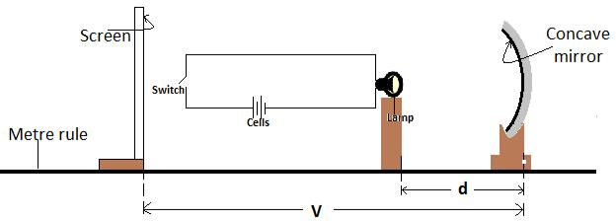

Fig. 15

**Procedure**

1. Set up the apparatus as shown in fig. 15 above.
2. Adjust the distance, =and close the switch.
3. Adjust the position of the screen to and fro until a sharp image of the filament of the bulb is seen on the screen.
4. Open switch.
5. Measure and record the distance, **V** from the mirror to the screen.

|  |  |  |  |  |  |  |
| --- | --- | --- | --- | --- | --- | --- |
| f) | Repeat the procedures (b) to (e) for values of, = | | | , , , and. | | |
| g) | Enter your results in a suitable table including values of | | | |  |  |
|  |
| h) | Plot a graph of |  | against **V**. |  |  |  |
|  |  |  |  |

1. Find the slope, **S** of the graph.
2. Calculate the focal length, ***f*** from the expression;

=



**Apparatus**:

2 cells, Torch bulb (lamp), Concave mirror, White screen, Switch, Mirror holder, Metre rule, paper



|  |  |
| --- | --- |
|  | 36 |

**2.06 Experiment 16**

**In this experiment, you will determine the focal length of a concave mirror.**

(a) Align the torch bulb, the concave mirror and the screen as shown in Fig. 16 below.

Concave mirror

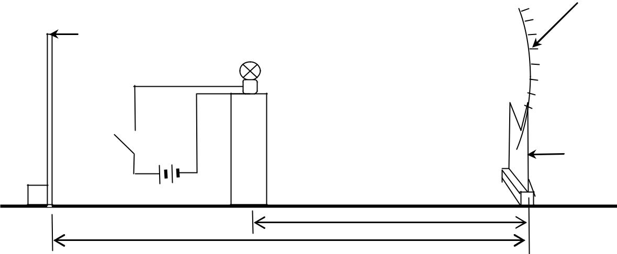

|  |  |
| --- | --- |
| White | Torch |
| screen |
| bulb |
|  |

|  |  |
| --- | --- |
| K | Mirror |
|  | holder |
|  | Dry cells |
| **Fig. 16** | d |
| *v* |
|  |

(b) Adjust the distance, d to 15 cm.

(c) Close switch K.

(d) Adjust the position of the screen to obtain a sharp image of the filament of the bulb on the screen.

(e) Open the switch K.

1. Measure the distance, *v*, of the screen from the mirror.
2. Repeat the procedures (b) to (f) for values of d = 20, 25, 30 35 and 40 cm.
3. Record your results in a suitable table including values of *dv* .
4. Plot a graph of *dv* against *v*.
5. Find the slope, S, of the graph.
6. Calculate the focal length, f, from the expression ;

f  S1



**Apparatus:** *Switch, 2 dry cells, torch bulb on its holder, connecting wires, mirror or lens holder,**concave mirror focal length = 10 cm and a white screen.*



|  |  |
| --- | --- |
|  | 37 |

**2.07 Experiment 17**

**In this experiment, you will determine the focal length, f, of concave mirror provided.**

(a) Fix the mirror in the holder.

Concave mirror

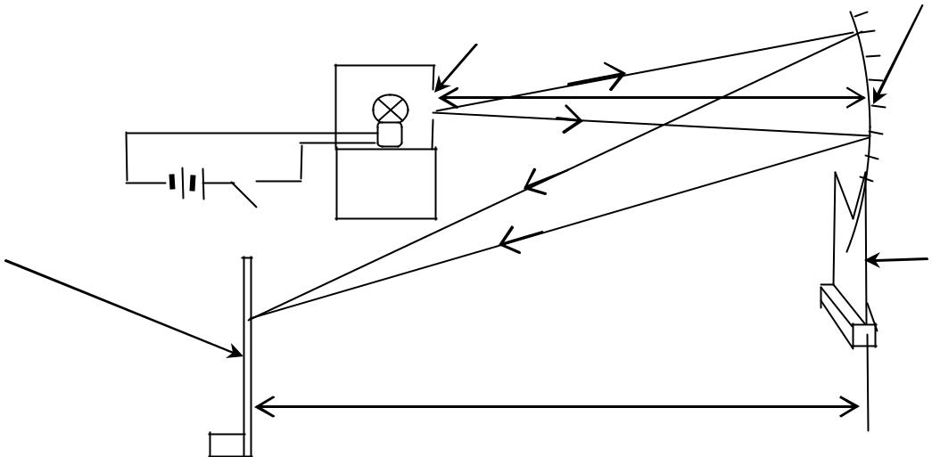

Illuminated object

**u**

|  |  |  |
| --- | --- | --- |
| White screen | Switch | Mirror |
|  |
|  |  |
|  |  | holder |

|  |  |
| --- | --- |
| **Fig. 17** | **v** |
|  |

1. Focus light from a window onto the screen.
2. Measure and record the distance, ***x***, between the screen and the mirror.
3. Arrange the mirror, the mounted bulb and the screen as shown in **Fig. 17** above.
4. Adjust the object distance **u** = 2.4***x***
5. Close the switch and move the screen until a sharp image of the object is formed on it.
6. Measure and record the image distance, **v**.
7. Repeat the procedures (e) to (g) for values of **u** = 3.2***x***, 4.0***x***, 4.8***x***, 5.6***x*** and 6.4***x***.
8. Enter your values in a suitable table including values of (**u + v**) and **uv**.
9. Plot a graph of **uv** against (**u + v**).
10. Find the slope, ***f***, of the graph.
11. Calculate the difference between ***f*** and ***x***.



**Apparatus:** *Switch, 2 dry cells, torch bulb on its holder, connecting wires, mirror or lens holder,**concave mirror focal length = 10 cm and a white screen.*



|  |
| --- |
| 38 |

**2.08 Experiment 18**

**In this experiment, you will determine the refractive index of, n, of a glass block.**

1. Using the drawing pins provided, fix the white sheet of paper on a soft board.
2. Place the glass in the middle of the sheet of paper and using pencil, mark the outline PQRS, of the glass block.

|  |  |  |  |  |
| --- | --- | --- | --- | --- |
| A | P1 |  |  |  |
|  |  |  |  |
|  | P2 | ***i*** |  |  |
|  | P | B |  | Q |
|  |  |  |  |
|  |  | ***y*** |  |  |
|  | S | C |  | R |
|  |  | ***x*** | P3 |  |
| **Fig. 18** |  |  | P4 | D |

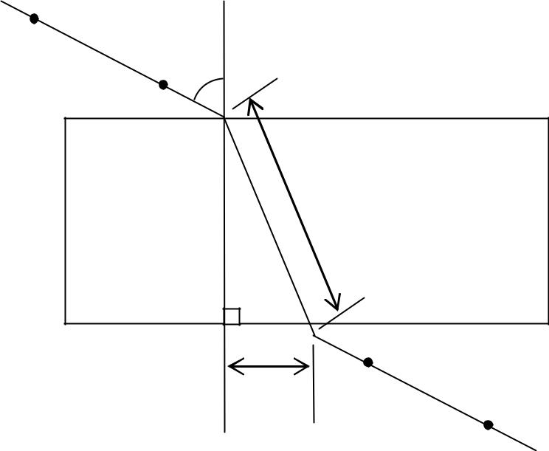

1. Remove the glass block and draw a perpendicular to PQ at B.
2. Draw a line AB such that angle, = 10*o* and replace the glass block.
3. Stick two pins P1 and P2 along AB.
4. Looking through the glass block from the opposite face SR, stick two other pins P3 and P4 in line with the images of pins P1 and P2.
5. Remove the glass block and draw a line through P3 and P4 to meet SR at C.
6. Join C to B, measure and record distances *x* and *y*.
7. Repeat procedures (f) to (g) for values of ***i*** equal to 20o, 30o, 40o, 50o and 70o.
8. Enter your results in a table, including values of*xy* .
9. Plot a graph ofagainst *xy* .
10. Find the slope, ***n***, of the graph.

**NOTE: Hand in the tracing Paper**



**Apparatus:** *Glass block; Soft board; 2 Thumb pins; 4 Optical pins; Plain sheet of paper*



|  |  |
| --- | --- |
|  | 39 |

**2.09 Experiment 19**

**In this experiment, you will determine the refractive index, n, of the material of** **the glass block**

**provided.**

(a) Fix the plane sheet of paper on a soft board using drawing pins.

Q

P1

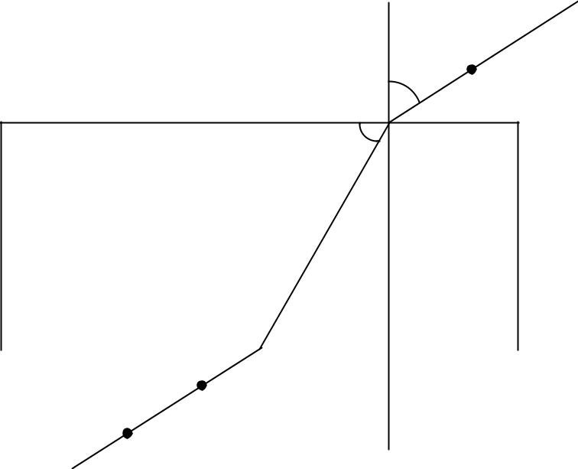

|  |  |  |
| --- | --- | --- |
|  | ***ί*** | P2 |
| A | O | B |
| ❑ |  |
|  |  |

|  |  |  |  |  |
| --- | --- | --- | --- | --- |
|  |  |  |  |  |
| D | | R | P | C |
|  |  | P3 |  |  |
| **Fig. 19** | | P4 |  |  |
|  |  | S |  |  |

1. Place the glass block on the sheet of paper so that it rests on its broader face and trace its outline ABCD.
2. Remove the glass block.
3. Measure angle *i* equal to 20o and draw line QO.
4. Fix pins P1 and P2 on line QO and then replace the glass block onto its outline.
5. Looking through the opposite face of the block fix pins P3 and P4 along RS such that they appear to be in line with the images of pins P1and P2.
6. Remove the pins and the glass block and draw a line through P3 and P4 to meet the glass block at R.
7. Join R to O and measure angle θ.
8. Repeat procedures (d) to (h) for values of *i* = 30o, 40o, 50o and 60o.
9. Record your results in a suitable table including values of sin *i* and cos θ.
10. Plot a graph of sin *i* against cos θ.
11. Find the slope, ***n***, of the graph.

**HAND IN THE WHITE TRACING PAPER**



**Apparatus:** *Glass block; Soft board; 2 Thumb pins; 4 Optical pins; Plain sheet of paper.*



|  |
| --- |
| 40 |

**2.10 Experiment 20**

**In this experiment, you will determine the refractive index, n, of the material of glass block given.**

|  |  |  |  |
| --- | --- | --- | --- |
| R | P1 |  |  |
|  |  | P2 |  |
| A | ❑ |  | B |
|  |  | O | r |
|  |  |  |

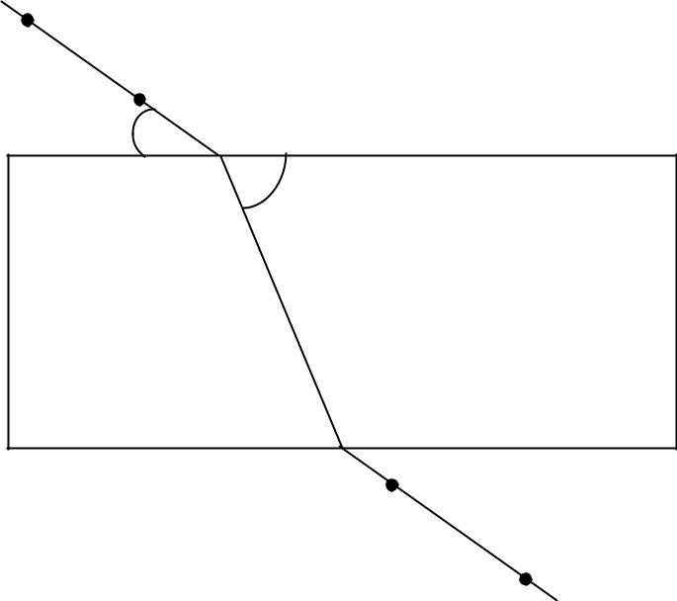

D P C

P3

|  |  |
| --- | --- |
| **Fig. 20** | Q |
|  |
|  | P4 |

1. Fix the plane sheet of paper on a soft board using drawing pins.
2. Place the glass block on the sheet of paper so that it rests on its broader face and trace its outline ABCD.
3. Remove the glass block.
4. At point O about 2 cm from A, draw a line RO at an angle θ = 80o to AB.
5. Fix pins P1 and P2 along RO and then replace the glass block onto its outline.
6. Looking through side DC, fix pins P3 and P4 such that they appear to be in a straight line with the images of P1 and P2 as shown in Fig. 20 above.
7. Remove the pins and the glass block and draw a line through P3 and P4 to meet DC at P.
8. Join P to O.
9. Measure angle r.
10. Repeat procedures (d) to(i) for θ = 70, 60, 50, 40 and 30o.
11. Record your results in a suitable table including values of cos θ and cos r.
12. Plot a graph of cos θ against cos r.
13. Find the slope, n, of the graph.

**HAND IN THE TRACING PAPER**



**Apparatus:** *Glass block; Soft board; 2 Thumb pins; 4 Optical pins; Plain sheet of paper.*



|  |  |
| --- | --- |
|  | 41 |

**2.11 Experiment 21.**

**In this experiment you will determine the refractive index, , of a glass block.**

|  |  |
| --- | --- |
| R | M |
| P1 |
|  | P2 |
| A | B |
|  | N |

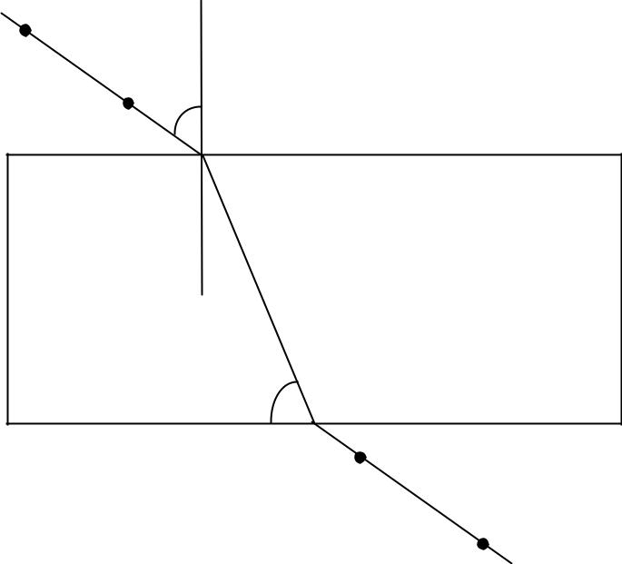

|  |  |  |
| --- | --- | --- |
|  |  |  |
| D | S | C |
|  |  | P3 |

|  |  |
| --- | --- |
| **Fig. 21** | T |
|  |
|  | P4 |

**Procedures**

1. Fix the plain sheet of paper on the soft board using drawing pins.
2. Place the glass block provided in the middle of the paper. Make sure that the glass block rests on its broad face as shown in figure 21.
3. Trace the outline ABCD of the glass block.
4. Remove the glass block.
5. Mark a point N on AB such that AN is a quarter of AB.
6. Draw a line MN perpendicular to AB.
7. Draw a line RN at an angle=to MN.
8. Fix two pins P1 and P2 on line RN.
9. Place the glass block on its outline.
10. Looking through the glass block from side CD, fix two pins, P3 and P4 so that they appear to be in line with the images of P1 and P2.
11. Remove the glass block and the pins and draw lines TS and SN.
12. Measure and record angle **θ**
13. Repeat procedures (g) to (l) for values of =, , , and .

n) Record your results in a suitable table including values of sin **α** and cos**θ**.

o) Plot a graph of sin **α** against cos**θ**

p) Find the slope of the graph.

**Note: Hand in you tracing paper**



**Apparatus**: Plain sheet of paper, rectangular glass block, soft board, 2 optical pins, 4 drawing pins,complete mathematical set.



|  |
| --- |
| 42 |

**2.12 Experiment 22**

**In this experiment, you are required to determine the refractive index n, of the glass using glass prism.**

**Procedure:**

(a) Place the glass prism on a plain sheet of paper on a soft board and draw its outline. Label the vertices

|  |  |
| --- | --- |
| PQR as seen in fig. 22 below. |  |
|  |

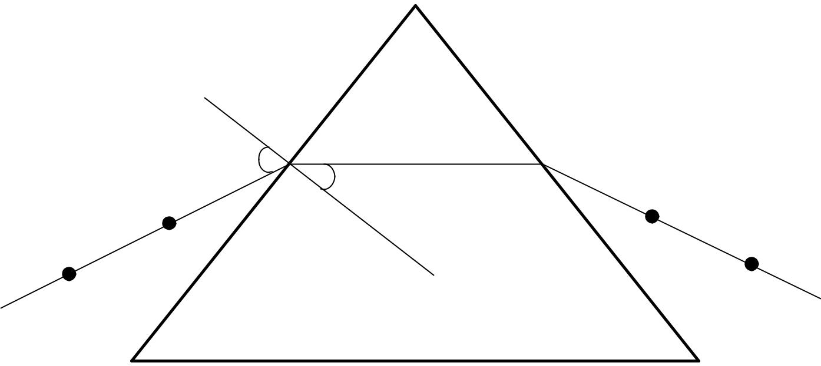

|  |  |  |  |
| --- | --- | --- | --- |
|  |  |  |  |
|  |  |
|  |  |  |
|  |  |  |
|  |  |  |  |
|  |  |  |
|  |  |  |  |
|  |  |  |  |
|  |  |  |
|  |  |  |  |

**Fig. 22**

1. At point A, 2cm from vertex Q, draw a normal to the line PQ.
2. Draw a line DA at an angle of incidence, *i* =300with the normal.
3. Stick pins P1 and P2 about 4cm apart on the line DA.
4. Replace the glass prism on its outline such that its vertices exactly match those on the outline.
5. Stick pins, P3 and P4 such that they are collinear with the image of P1 and P2.
6. Remove the prism and the pins. Draw a line through the position of the pins P3 and P4 to meet RQ at B.
7. Join B to A measure and record angle r.
8. Repeat procedure (c) to (h) for values of i = 400,500,600and 700.
9. Enter your results in a suitable table including values of sin i and sin r.
10. Plot graph of sin (along the vertical axis) against sin (a long the horizontal).
11. Find the slope, n, of your graph.

**Note: Hand in your tracing paper**



**Apparatus**: Plain sheet of paper, rectangular glass block, soft board, 2 optical pins, 4 drawing pins,complete mathematical set.



|  |  |
| --- | --- |
|  | 43 |

**2.13 Experiment 23.**

**In this experiment, you will determine the focal length, f, of the lens, L, provided.**

(a) Arrange the cross wires, the lens, L and the screen in a straight line as shown in Fig. 23 below.

|  |  |  |  |  |  |
| --- | --- | --- | --- | --- | --- |
| Cross wires |  | Lens holder | White screen | | |
|  |  | Lens, L | | |
| Torch bulb |  |  |
|  |  |  |  |  |
|  |  |  |  |  |  |

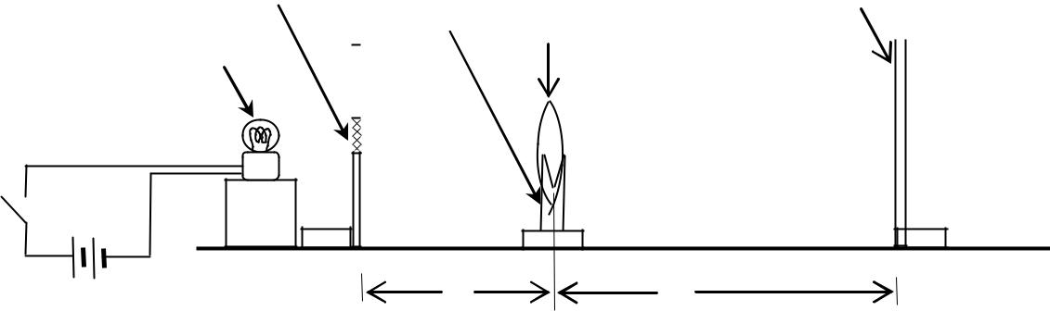

K

|  |  |  |  |
| --- | --- | --- | --- |
| **Fig. 23** | Dry cells | *u* | *v* |
|  |

1. Adjust the distance, *u* between the cross wires and the lens to 30 cm.
2. Close the switch, K so that the bulb lights.
3. Move the screen to and fro until a sharp image of the cross wires is formed on the screen.
4. Read and record the image distance, *v*, between the lens and the screen.
5. Repeat procedures (b) to (e) for values of *u* equal to 40, 50, 60 and 70 cm.
6. Record your results in a suitable table including values of *uv* .
7. Plot a graph of *uv* against v.
8. Find the intercept, *f1*, on the *v* – axis.
9. Find the slope, *S*, of the graph.
10. Calculate, ***f2***, from, ***f2*** = *S*1 .

|  |  |  |  |
| --- | --- | --- | --- |
| (l) Find ***f*** from the expression; | *f*  | *f*1 *f* 2 | . |
| 2 |
|  |  |  |



**Apparatus:** *Switch, 2 dry cells, torch bulb in its holder, connecting wires, cross wires, lens holder,**convex lens focal length = 10 cm and a white screen.*



|  |
| --- |
| 44 |

**2.14 Experiment 24.**

**In this experiment, you will determine the focal length of a converging lens.**

(a) Mount the lens provided and place it facing the window.

(b) Place the screen behind the lens and adjust it until a clear image of the distant object is obtained.

(c) Measure and record the distance, d, between the lens and the screen.

|  |  |  |  |  |  |  |
| --- | --- | --- | --- | --- | --- | --- |
| Wire | Lens | | | | | |
| Gauze |  |  |  |  |  | White screen |
|  |  |  |  |  |  |
|  |  |  |  |  |  |  |
|  |  |  |  |  |  |  |

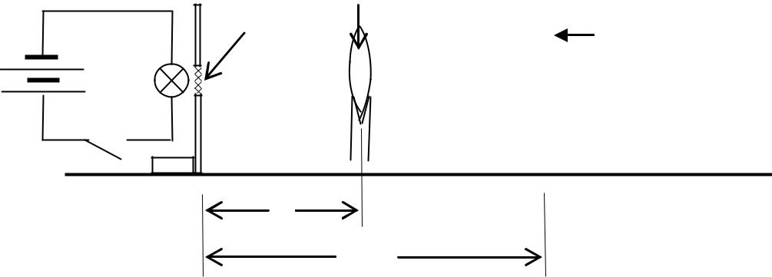

|  |  |
| --- | --- |
|  | *x* |
| **Fig. 24** | *y* |

(d) Arrange the bulb, wire gauze, lens and screen as shown in Fig. 24 above.

(e) Adjust the lens so that the distance, *x* between the wire gauze and the lens is equal to 2.5d.

1. Close the switch and move the screen until a clear image of the wire gauze is obtained on the screen.
2. Measure and record the distance, *y*, between the wire gauze and the screen.
3. Repeat procedures (e) to (g) for values of *x* = 3.0d, 3.5d, 4.0d and 4.5d.
4. Record your results in a suitable table including values of (*y* – *x*) and *x*(*y* – *x*).
5. Plot a graph of (*y* – *x*) against *x*(*y* – *x*).
6. Determine the slope, S, of your graph.
7. Calculate *f* from the relation:

*S* 1*f* .



**Apparatus:** *Switch, 2 dry cells, torch bulb on its holder, connecting wires, cross wires, lens holder,**convex lens of focal length = 10 cm and a white screen.*



|  |  |
| --- | --- |
|  | 45 |

**2.15 Experiment 25**

**In this experiment, you will determine the focal length, f, of the lens provided.**

(a) Focus the image of a distant object onto the screen provided.

(b) Measure and record the length, ***fo***, between the screen and the lens.

(c) Connect the bulb, the dry cells and switch, K, in series as shown in figure 34 below.

White screen

Wooden Lens

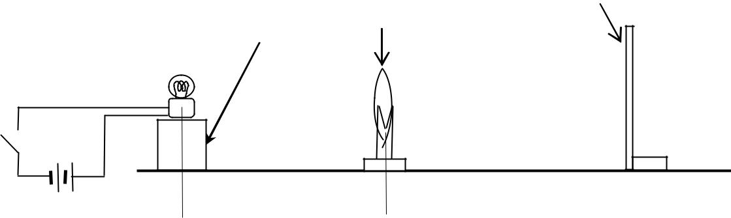

K

x y



**Fig. 25**

(d) Arrange the bulb, lens and the screen as shown in Fig. 25 above.

(e) Adjust distance, ***x***, between the bulb and the lens to 1.5***fo***

1. Close the switch, K.
2. Adjust the position of the screen to obtain a clear image on it.
3. Measure the distance, y, between the lens and the screen.
4. Repeat procedures (e) to (h) for ***x*** = 2.0F, 2.5F, 3.0F and 4.0F.
5. Tabulate your results including values of ***xy*** and ***x + y.***
6. Plot a graph of ***xy*** against ***x + y***.
7. Find the slope, ***f***, of the graph.



**Apparatus:** *Switch, 2 dry cells, torch bulb in its holder,a wooden small piece of block, connecting wires,**cross wires, lens holder, convex lens of focal length = 15 cm or 20 cm and a white screen.*



|  |
| --- |
| 46 |

**3.16: Experiment 26.**

**In this experiment, you will determine the focal length of the converging lens provided.**

1. Mount the lens in the holder provided and place it facing a window.
2. Place a white screen behind the lens.
3. Adjust the position of the white screen until a clear image of a distant object is obtained on it.
4. Measure and record the distance, *f*, between the lens and the white screen.
5. Connect the bulb, dry cells and the switch, K in series.
6. Arrange the bulb, wire gauze, lens and the white screen as shown in figure 26 below.

Wire gauze White screen

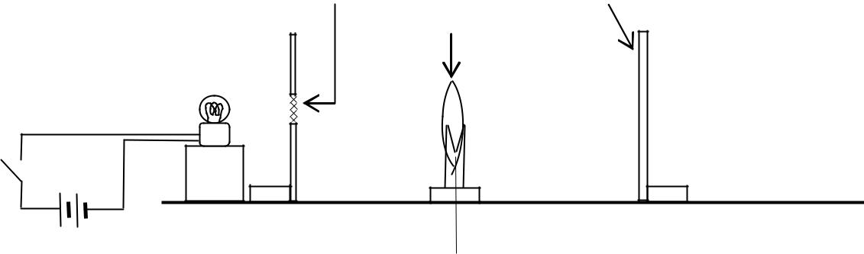

Lens

K

***x***  *y*



**Fig. 26**

1. Adjust the lens so that the distance, ***x***, between the wire gauze and the lens is equal to 2.0*f*.
2. Close switch, K, and move the white screen until a clear image of the wire gauze is obtained on the white screen.
3. Measure and record the distance, y, between the lens and the white screen.
4. Open switch, K.
5. Repeat procedures (g) to (j) for values of ***x*** = 2.4*f*, 2.8*f*, 3.2*f* and 3.6*f*.
6. Record your results in a suitable table including values of ***xy*** and (***x + y***).
7. Plot a graph of ***xy*** against (***x + y***).
8. Determine the slope, **F**, of the graph, where **F**is the focal length of the lens.

|  |  |  |
| --- | --- | --- |
| (o) Find the value of : | *F*  *f* | . |
|  |
|  | *f* | |



**Apparatus:** *Switch, 2 dry cells, torch bulb on its holder, a wooden small piece of block, connecting**wires, lens holder, convex lens of focal length = 15 cm and a white screen.*



|  |  |
| --- | --- |
|  | 47 |

**3.17 Experiment 27**

***In this experiment, you will determine the power, P of a cylindrical water lens using two methods.***

**Procedure**

**METHOD I**

1. Measure and record the external diameter, D, of the 250ml glass beaker provided.
2. Draw using a pen, a vertical line along the strip of the paper provided.
3. Stick the strip of paper vertically on the side of the glass beaker using the pieces of cello tape provided.
4. Place the beaker containing water between the screen and the illuminated object such that the vertical line on the beaker faces you as shown in the figure 27 (a) below.

Beaker

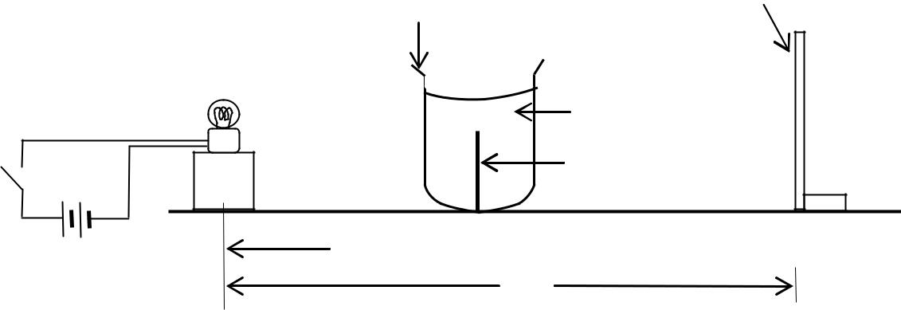

White screen

Water

Vertical line

K

*x*

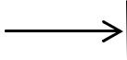

**Fig. 27 (a)**

*y*

1. Pour water into the beaker up to the 250 ml mark.
2. Adjust the distance, ***x***, to 20.0 cm.
3. Adjust the position of the screen until a sharp vertical line image of the bulb is formed on it.
4. Measure and record the distance, **y**, of the screen from the bulb.
5. Calculate the value of, **P,** from the expression;

= ( − )

1. Repeat the procedure (f) to (i) for ***x*** = 30.0 cm.
2. Calculate the average value of **P**.

**DO NOT DISMANTLE THE SET UP**



|  |
| --- |
| 48 |

**METHOD II**

White screen

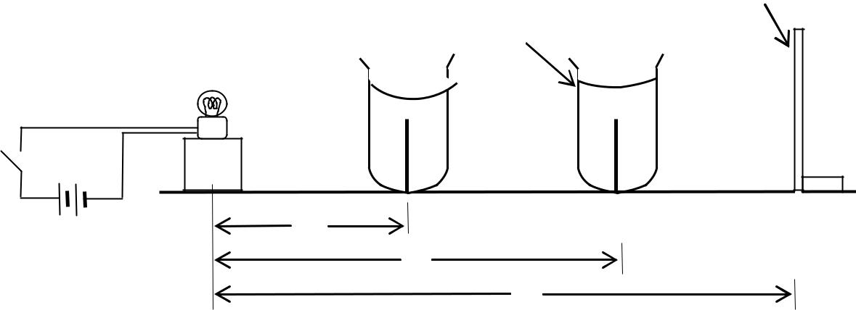

Beaker

K

|  |  |
| --- | --- |
|  | ***b*** |
| **Fig. 27(b)** | ***u*** |
|  |
|  |

1. Adjust the distance between the bulb and the screen to , = 5Dcm as shown in the fig.37(b) above.
2. Starting with the beaker near the screen, move the beaker towards the bulb until a sharp diminished vertical line image of the bulb is formed on the screen.
3. Measure and record the distance, **u**, of the beaker from the bulb.
4. Keeping **,** constant, move the beaker further towards the bulb until another sharp magnified image is formed on the screen.
5. Measure and record the new distance, **b**, of the beaker from the bulb.
6. Repeat procedure (a) to (e) for values of = 6D, 7D, 8D, 9 D and 10D cm.

g) Tabulate your results including values of 2 , = − , 2 = 2 − 2 .

1. Plot a graph of against .
2. Find the slope, **S** of the graph.
3. Calculate the value of, **P,** from the expression;

=

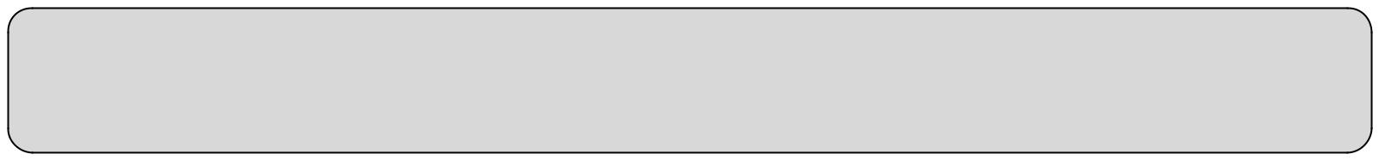

**Apparatus:** 2 dry cells, 1 double cell holder, 1 torch bulb, a bulb holder, 1 switch, 1 250ml glass beaker,water, 1 screen, connecting wires, 1 meter rule, wooden block, 1 piece of paper 2cm X 4cm and 2 pieces of transparent cello tape, vernier calipers.



|  |  |
| --- | --- |
|  | 49 |

4. ELECTRICITY EXPERIMENTS

**Constantine wire SWG 28 and SWG 30:** For experiments that have only the ammeter, SWG 30 is preferred because it has a smallerresistance leading to bigger values of current, I that are easier to read.

Similarly, for experiments that have only the Voltmeter, SWG 28 is preferred because it has a higher resistance leading to bigger values of potential difference, V that are easier to read.

**Bulbs, 2.5V.** A 2.5V bulb in a circuit will give light only if the P.d across it 2.5V or more. This therefore means that a bulb in a circuitmay light or may not. As long as the connected Ammeters and Voltmeters deflect, the student should continue with the experiment regardless of whether the bulb lights or not.

In some experiments, the bulb may not give light at first but as the experiment progress, it gives light. This means that initially, the pd across the bulb was far below 2.5V. In other experiments, the bulb may give light at first but as the experiment progress, it goes off. This means that the P.d across the bulb has fallen below 2.5V.

The connections should be firm enough and the circuits should be connected from the positive of the battery to the negative of the battery.

To make the connections easily, first place the instruments as they appear in the circuit diagram. The terminals must correspond i.e,

* The positive **(RED)** knobs (terminals) of the ammeters or voltmeters must be connected to the positive side of the cell(s) in the circuit.
* The negative **(BLACK)** knobs (terminals) of the ammeters or voltmeters must be connected to the negative side of the cell(s) in the circuit.

In this way, the meters may be facing away from you, but after connecting, you can turn the meters to face you for easy reading.

* If the terminals are interchanged, (i.e when Positive is connected to negative), the meters will deflect in the opposite direction. The pointer will move to the left of the zero (0) mark. You may be tempted to think that the meter is not working because it deflects by a small amount to the left of zero. When it deflects this way, the student should inter change the terminal connections.
* All the connections should be firm. If not the meters may not deflect or if they do, the deflections will not be steady! This makes taking the reading hard.
* After taking the reading the student should remember to switch off the circuit to avoid un necessary drop in the e.m.f of the cell(s)

during the experiment.

Voltmeters are calibrated differently e.g 0-3V, 0-5V. Some voltmeters have two scales; e.g 0-3V and 0-5V, 0-3V and 0-6V. To use the scale of range **0-3V,** the knob (terminal) marked **3V** is used with the terminal marked **COM.**

|  |  |  |
| --- | --- | --- |
| **Position P:** | **Position P:** |  |
| In the figure above, taking the 0- 3V scale, | |
|  |
| In the figure above, taking the 0- 1A scale, |
| 10 divisions = 0.5 V | |
| 10 divisions = 0.2A |
| 1 division | = 0.05 V |
| 1 division = 0.02A |
| Ammeter reading = 0.5 + (0.05 x 3) | |
| Ammeter reading = 0 + (0.02 x 8) |
|  | = 0.5 + 0.15 V |
| = 0.16A |  |
|  | = 0.65 V |
|  |  |
|  |  |  |
|  |  |  |
|  |  |  |

**4.01: Experiment 31.**

**In this experiment, you will determine a constant of the wire provided.**

(a) Connect the circuit shown in the figure 31 below starting with a length of the wire, y, equal to 30 cm.

Dry cells

Wire

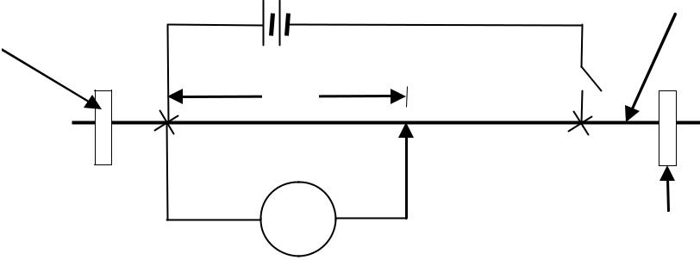

Cello tape

|  |  |
| --- | --- |
| *y* | K |

|  |  |
| --- | --- |
| **Fig. 31** | V |
| Cello tape |

1. Close switch K.
2. Read and record the reading, V , of the voltmeter
3. Open switch K.
4. Repeat procedures (c) to (e) for the values of *y* = 40, 50, 60 and 70 cm.
5. Record your results in a suitable table including values of V1 and 1*y* .
6. Plot a graph of V1 against 1*y* .
7. Find the slope, s, of the graph.

|  |  |  |
| --- | --- | --- |
| (i) Determine the intercept, c, on the | 1 | axis. |
| V |
|  |  |

1. Calculate the constant of the wire,  , from the expression;
   *  100cs



**Apparatus:** *Voltmeter (0-3 V); 2 Dry cells; Jockey; Cello tape; 5 pieces of connecting wires; Metre rule;**Switch; Nichrome (28SWG).*



51

|  |  |
| --- | --- |
|  |  |

**4.02 Experiment 32**

**In this experiment, you will determine the resistivity, ρ, of the bare wire, W.**

(a) Connect the ammeter A, switch K, dry cell E and wire W as shown in figure 42 below.

|  |  |  |
| --- | --- | --- |
| Bare wire | K | E |
|  |  |
| Cello tape |  | A |
|  |  |

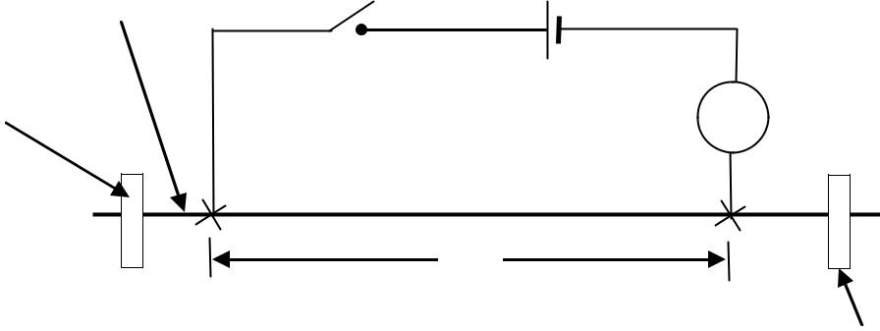

d

**Fig. 32** Cello tape

1. Adjust distance, d, of the wire to 20 cm.
2. Close the switch, K, and record the reading, I, of the ammeter.
3. Repeat the procedures (b) and (c) for values of d equal to 30, 40, 50, 60, 70 and 80 cm.
4. Record your results in a suitable table including values of 1I against d.
5. Determine the slope, S, of the graph.
6. Calculate the resistivity, ρ, of the wire from; **ρ = 1.6 x 10-5** **S.**



**Apparatus:** *Ammeter (0**–**1 A); 1 Dry cell (Size D); Jockey; Cello tape; 5 pieces of connecting wires;**Metre rule; Switch; Constantan (28 SWG) .*



52

|  |  |
| --- | --- |
|  |  |

**03: Experiment 33.**

**In this experiment, you will determine the resistivity,** **, of the material of the material of the wire provided.**

|  |  |  |  |
| --- | --- | --- | --- |
| Bare wire | K |  |  |
| Cellotape |  | A | Jockey |
|  |  |
|  | *ι* |  |
|  |  |  |
| **Fig. 43** | V |  |  |
|  |  | Cellotape |
|  |  |  |

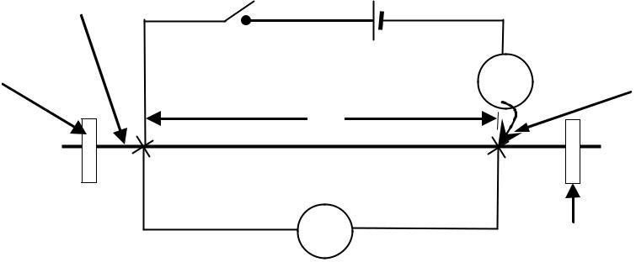

1. Connect the circuit as shown in figure 43 above.
2. With the switch, K, open, adjust the position of the jockey along the bare wire such that *l* = 0.2 m.
3. Close the switch K.
4. Note the ammeter reading, I and voltmeter reading V.
5. Open the switch K.
6. Repeat procedures (b) to (e) for values of *l* = 0.30, 0.40, 0.50, 0.60 and 0.70m.
7. Enter your results in a suitable table including values of VI .
8. Plot a graph of VI against *l*
9. Find the slope, S, of the graph.
10. Calculate the resistivity, , of the material of the bare wire from the expression,
    * **= 2.04 X 10-7 S.**

**Apparatus:** *Voltmeter (0-3 V); Ammeter (0**–**1 A); 1 Dry cell; Jockey; Cello tape; 5 pieces of connecting**wires; Metre rule; Switch; Nichrome (28SWG)*



53

**4.04 Experiment 34**

**In this experiment, you will determine the internal resistance of a dry cell provided.**

1. Stretch and fix wire P on a metre rule with a cellotape.
2. Connect the dry cell, 2 resistor and a voltmeter as shown in figure 34 below.

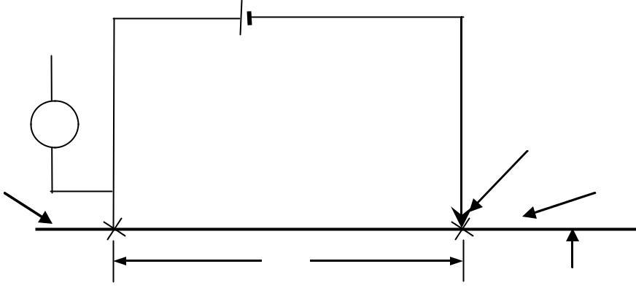

|  |  |  |  |  |  |  |  |  |  |  |
| --- | --- | --- | --- | --- | --- | --- | --- | --- | --- | --- |
|  |  |  |  |  |  |  |  | Dry cell | | |
| Voltmeter | V | | |  |  |  | 2 Ω | Jockey | | |
|  |  |  |
|  |  |  |  |  |
|  |  |  |  |  |  |  |  |
| Cellotape |  |  |  |  |  |  |  |  |  | Cellotape |
|  |  |  |  |  |  |  |  |  |
|  |  |  |  |  |  |  |  |  |  |  |
|  |  |  |  |  |  |  |  |  |  |  |

|  |  |  |
| --- | --- | --- |
| **Fig.34** | y | Bare wire, **P** |
|  |

1. Place the jockey on wire P such that y is equal to 30 cm. Record the voltmeter reading *v*.
2. Repeat procedure (c) above for values of y equal to 40, 50, 60, 70 and 80 cm
3. Record your results in a suitable table including values of Vy .
4. Plot a graph of Vy (on vertical axis) against y( on horizontal axis)
5. Find the slope, s, of the graph.
6. Find the value **n** of Vy when y = 0 cm.
7. Calculate the e.m.f, E of the dry cell from;

E  3 102

S

1. Calculate the internal resistance, **r** of the dry cell from; **r = 2nE – 1**.



**Apparatus:** *Voltmeter (0-3 V); Resistor 2**; Dry cell; Jockey; Cello tape; 5 pieces of connecting wires;**Metre rule; Nichrome (28 SWG).*



|  |  |
| --- | --- |
| 54 |  |

**4.05 Experiment 35:**

**In this experiment, you will determine the internal resistance, *r* of a pair of dry cells.**

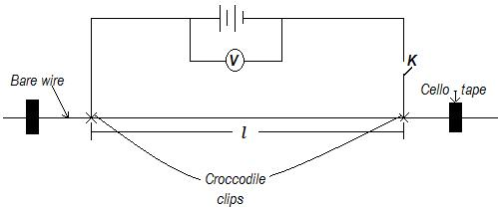

**Fig.35**

**Procedure**

1. Connect your apparatus as shown in the figure 35 above.
2. Adjust the distance ***l***= 20
3. Read and record the voltmeter reading, **Vo**.
4. Close Switch K
5. Read and record the reading of the voltmeter, **V1**
6. Open switch K
7. Repeat procedures (d) to (e) with values of ***l***=, , , and.

|  |  |  |  |  |  |  |
| --- | --- | --- | --- | --- | --- | --- |
|  |  |  |  |  |  |  |
| (h) Record your values in a suitable table, including values of= | | | |  | − and |  |
|  |
|  |  |  |  |  |  |  |
|  |  |  |  |  |  |
|  |  |  | |  |  |  |
| (i) | Plot a graph of **V** against |  |  |  |  |  |
|  | |  |  |  |
|  |  |  |  |  |
| (j) | Find the slope, ***S*** of your graph | | |  |  |  |

(k) Calculate the resistance per metre, ***r***, from the expression;

= 420

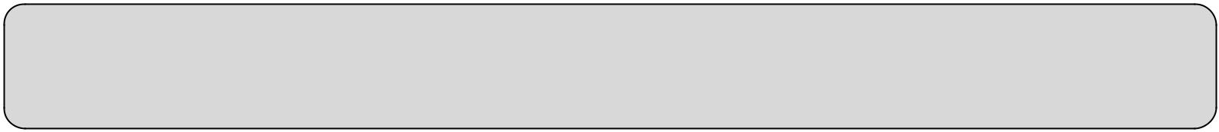

**Apparatus:** 2 cells, 2 single cell holders, switch, K, bare wire 110 m long (Constantine wire SWG28),Voltmeter (0 – 3) V, Cello – tape, metre rule, 2 crocodile clips, 6 Pieces of connecting wires of about 30 cm each.



55



**4.06 Experiment 36*:***

**In this experiment, you will determine the diameter, of the bare wire given.**

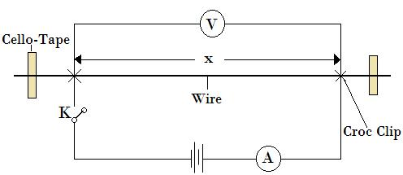

**Procedure**

**Fig.36**

1. Fix the bare wire on the metre rule using the cello – tape.
2. Connect the circuit as shown in the figure 36 above.
3. Adjust the position of the length, = ..
4. Close the switch, **K**.
5. Read and record the ammeter reading, and voltmeter reading, .
6. Open the switch, **K**.
7. Repeat the procedures c) to f) for values of = . , . , . , ...
8. Record your results in a suitable table including values of .
9. Plot a graph of against .
10. Find the slope, of the graph.
11. Calculate the diameter, ***D*** in metres of the bare wire from the expression.

|  |  |
| --- | --- |
| = | .− |
|  |
|  |  |



**Apparatus:** 2 cells, 2 single cell holders, switch, K, bare wire 110 m long (SWG28) , Ammeter (0–1)A, Voltmeter(0 – 3) V, Cello – tape, metre rule, 2 crocodile clips, 5 Pieces of connecting wires of about 30 cm each.



|  |
| --- |
| 56 |

**4.07 Experiment 37:**

**In this experiment, you will determine the internal resistance, and the electromotive force, of the cell.**

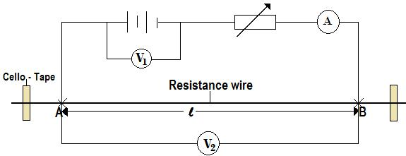

**Fig.37**

**Procedure:**

1. Fix the resistance wire on the metre rule using the cello – tape.
2. Connect the circuit as shown in the fig. 37 above such that AB = 15 cm.
3. Adjust the rheostat until the ammeter reading, = ..
4. Connect the voltmeter across the cells and record its reading, .
5. Disconnect the voltmeter and connect it across AB. Read and record its reading,
6. Repeat procedures c) to e) for values of
7. Enter your result in a suitable table.
8. On the same axes,
   1. Plot a graph ofagainst.
   2. Plot a graph ofagainst.
9. Read and record the value of current,

= . , . , . , . . .

and voltmeter, where the two graphs intercept.

1. Calculate the value of resistance, **r** from the expression;

=

**Apparatus:** 2 cells, 2 single cell holders, switch, K, bare wire 110 m long (SWG28) , Ammeter (0–1)A, Voltmeter (0 – 3) V, Rheostat (0 - 50Ω), Cello – tape, metre rule, 2 crocodile clips, 5 Pieces of connecting wires of about 30 cm each.



|  |  |
| --- | --- |
| 57 |  |

**4.08 Experiment 38:**

**In this experiment, you will determine a constant,** Ω **of the resistor,**

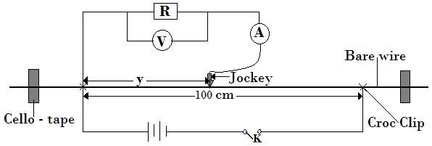

**Fig.38**

**Procedure**

1. Connect the circuit as shown in the fig.38 above.
2. Beginning with length, = ., close the switch, .
3. Read and record the voltmeter reading, and the ammeter reading, .
4. Open the switch, .
5. Repeat the procedures (b) to (d) for the values of = ., . , . , ...
6. Record your values in a suitable table including the values of and .

g) Plot a graph of against

h) Determine the slope, Ω of the graph.



**Apparatus:** 2 cells, 2 single cell holders, switch, K, bare wire 110 m long SWG28 , Ammeter (0–1) A,Voltmeter (0 – 3) V, Resistor **R**, Cello – tape, metre rule, 2 crocodile clips, 5 Pieces of connecting wires of about 30 cm each.



58

**4.09 Experiment 39:**

**In this experiment, you will determine resistance of the filament of the torch bulb provided.**

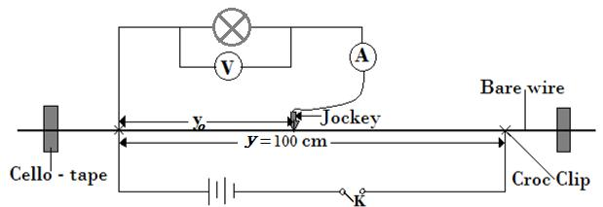

**Fig.39**

**Procedure**

1. Connect the circuit as shown on the diagram above.
2. Starting with =**cm** and= **cm**, close the switch, K.
3. Read and record the voltmeter reading**,** and the ammeter reading, **.**
4. Open the switch, K.
5. Repeat the procedures (b) to (d) for values of; = ., . , . , .and .**m.**
6. Enter your results in a suitable table.
7. Plot a graph of against **I**.
8. Determine the slope, ***S*** of the graph**.**



**Apparatus:** 2 cells, 2 single cell holders, switch, K, bare wire 110 m(SWG28) , Ammeter (0–1) A,Voltmeter (0 – 3) V, Cello – tape, metre rule, Torch bulb, 2 crocodile clips, 5 Pieces of connecting wires of about 30 cm each.



59

**4. 10: Experiment 40.**

**In this experiment, you will determine the ratio, p, of the internal resistance of a pair of dry cells to the resistance per centimetre of the wire labelled, W.**

(a) Fix the bare wire labelled, W, on the bench using cello tape.

(b) Connect the circuit as shown in the figure 40 below.

Dry cells

K

Bare

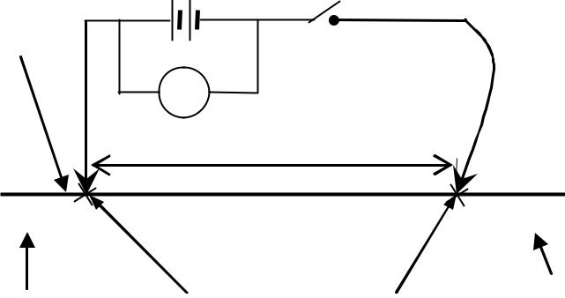

V

*l*

|  |  |  |  |  |  |  |  |
| --- | --- | --- | --- | --- | --- | --- | --- |
|  |  |  |  | Crocodile clips |  |  |  |
| **Fig. 40** | Cellotape | | | Cellotape | | |
|  |  |  |  |  |  |  |

(c) Starting with a length, *l* = 20 cm, read and record the voltmeter reading, V0.

(d) Close the switch, K.

(e) Read and record the voltmeter reading, V1.

1. Open the switch, K.
2. Repeat the procedures (c) to (f) for values of ***l***= 30, 40, 50, 60 and 70 cm.
3. Record your values in a suitable table including values of V = V0 – V1 and Plot a graph of V against *l.*
4. Determine the slope, **p** of the graph.



**Apparatus:** *Voltmeter (0-3 V); 2 Dry cells; Jockey; Cello tape; 5 pieces of connecting wires; Metre rule;**Switch, Constantan wire(28 SWG) labelled W.*



60

**4.11 Experiment 41**

**In this experiment, you will determine the constant, Lo, of the bicycle spoke**

|  |  |  |  |  |  |  |  |  |  |  |  |  |  |  |
| --- | --- | --- | --- | --- | --- | --- | --- | --- | --- | --- | --- | --- | --- | --- |
|  |  |  |  |  |  |  |  |  | Bicycle spoke | | | | | |
|  | Bare wire | | |  |  |  |  | K |  |  |  |  |  |  |
|  |  |  |  |  |  |  |  |  |  |  |
|  |  |  |  |  |  |  |  |  |  |  |  |
|  |  |  |  |  |  |  |  |  |  |  |
|  |  |  | A | | |  |  |  |  |  |  |  |  |  |
|  |  |  |  |  |  |  |  | |  |  |  |  |  |  |
|  |  |  |  |  |  |  | ***x*** |  |  |  |  |  |  |  |
|  |  |  |  |  |  |  |  |  |  |  |  |
|  | |  |  |  |  |  |  |  |  |  |  | |  | |
|  |  |  |  |  |  |  |  |  |  |  |  |  |  |  |
| **Fig. 41** | | | | | | Crocodile clips | | |  | Cellotape | | | | |
|  | Cellotape | | | | |  |  |  |  |  |  |  |  |  |
| (a) | Connect the circuit as shown in figure 41. | | | | | | | |  |  |  |  |  |  |
| (b) | Starting with a length, ***x*** = 0.800 m, close the switch, K. | | | | | | | | | | | | | |
| (c) | Record the ammeter reading, I. | | | | |  |  |  |  |  |  |  |  |  |
| (d) | Open the switch K. | | | | |  |  |  |  |  |  |  |  |  |
| (e) | Repeat procedures (b) to (d) for values of ***x*** = 0.700, 0.600, 0.500, 0.400 and 0.300m. | | | | | | | | | | | | | |
| (f) | Record your results in a suitable table including values of | | | | | | | | | | | 1 | | . |
|  |  |
|  |  |  |  |  |  |  |  |  |  |  |  | I | | |

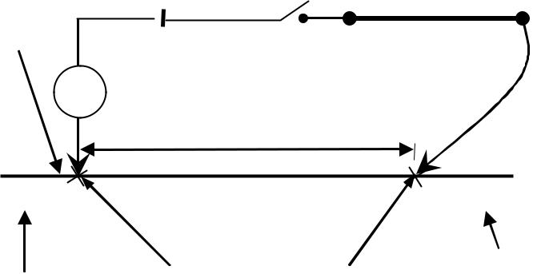

(g) Plot a graph of 1I against *x*.

(h) Find the slope, S, of the graph.

(i) Read the intercept, C, on the 1I axis.

(j) Calculate the value of **L**o from the expression: =

**Apparatus:** *Ammeter (0**–**1 A); 1 Dry cell; Jockey; Cello tape; 5 pieces of connecting wires; Metre rule;**Switch; nichrome (28SWG); Bicycle spoke.*



61

**4.12 Experiment 42**

**In this experiment, you will determine the resistance of a resistor.**

1. Connect the dry cells, resistance wire, resistor **R**, voltmeter **V** and ammeter **A** as shown in the figure 42 below.

K

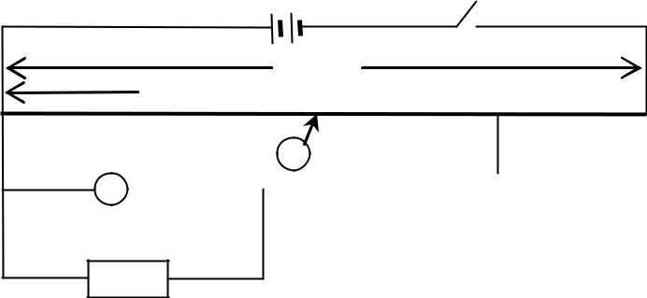

100 cm y



A

V Resistance wire



**Fig. 42**

**R**

1. Adjust the length, y, of the resistance wire to 20 cm.
2. Close switch K and record the reading V of the voltmeter and I of the ammeter.
3. Open switch K.
4. Repeat procedures (b) to (c) for values of y equal to 30, 40, 50, 60 and 70 cm.
5. Record your results in a suitable table.
6. Plot a graph of V against I.
7. Find the slope, S of the graph.



**Apparatus:** *Voltmeter (0-3 V); Ammeter (0**–**1A); Resistor 5; 2 Dry cells; Jockey; Cello tape; 5 pieces**of connecting wires; Metre rule; Switch; Nichrome (28SWG).*



62

**4.13 Experiment 43**

**In this experiment, you will determine the resistance of a resistance wire.**

1. Fix the resistance wire provided firmly on the bench.
2. Connect the circuit as shown in figure 43 below with the length *PQ* = 20 cm.

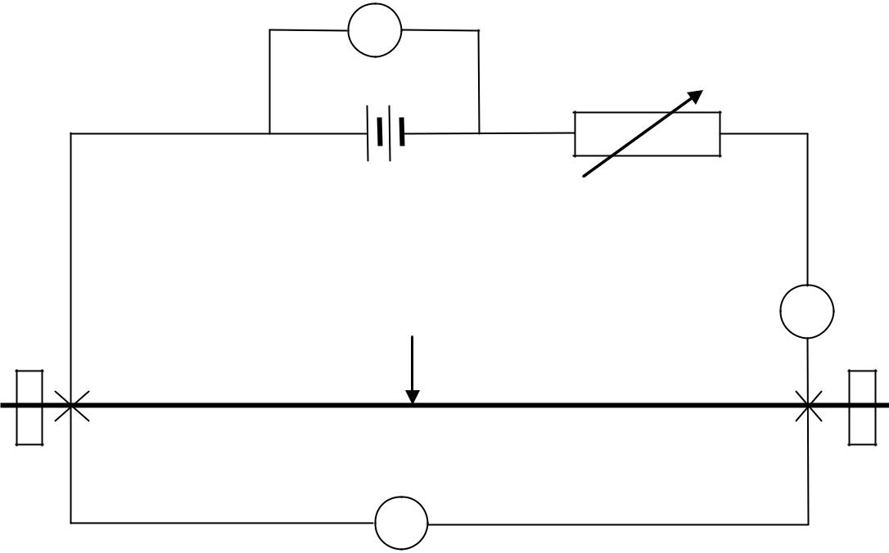

V1

|  |  |  |
| --- | --- | --- |
|  | Resistance wire | A |
|  |  |
| P |  | Q |

|  |  |
| --- | --- |
| **Fig. 43** | V2 |
|  |

(c) Adjust the rheostat so that the ammeter reading I = 0.6 A.

(d) Connect a voltmeter across the cells and record its reading V1.

(e) Disconnect the voltmeter and connect it across PQ. Record its reading V2.

(f) Repeat procedures (c), (d) and (e) for values of I = 0.5, 0.4, 0.3, 0.2 and 0.1 A.

(g) Record your results in a suitable table.

(h) On the same axes, plot a graph of

(i) V1 against I. (ii) V2 against I.

(i) Read the values of current Io and voltage Vo where the two graphs meet.

(j) Calculate the value of Vo .

Io



**Apparatus:** *Voltmeter (0-3 V); ammeter (0**–**1 A); Rheostat (0 - 50); 2 Dry cells; Jockey; Cello tape; 8**pieces of connecting wires; Metre rule; Switch; Nichrome (28SWG).*



63

**4.15 Experiment 45.**

**In this experiment, you will determine the resistance, R, of the filament of the torch bulb provided.**

1. Fix the bare wire, P, on the bench using pieces of cellotape.

|  |  |  |
| --- | --- | --- |
|  | Dry cells | Cellotape |
| K |  |
|  |  |

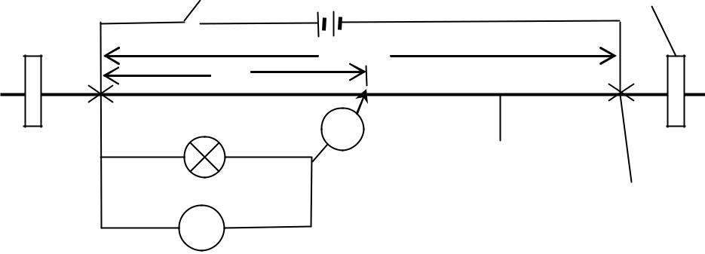

|  |  |
| --- | --- |
| *x* | *x*o |
|  |
| Bulb | A |
|  | Bare wire, P |

Crocodile clip

**Fig. 45** V

1. Connect the circuit as shown in the figure 45 above.
2. Starting with length, *x*o = 1.00 and *x* = 0.20 m, close the switch, K.
3. Read and record the voltmeter reading, V, and the ammeter reading, I.
4. Open switch, K.
5. Repeat procedures (c) to (e) for values of ***x*** = 0.30, 0.40, 0.50, 0.60 and 0.70 m.
6. Record your results in a suitable table.
7. Plot a graph of V against I.
8. Determine the slope, S, of the graph.



**Apparatus: 1***Voltmeter (0-3 V);1 Ammeter (0 -1); 2 Dry cells; Jockey; 2 pieces of Cello tape; 10 pieces**of connecting wire about 30cm long;1 Metre rule; Constantan (28 SWG); 1 bulb in a holder,1 switch.*



64

**4.16 Experiment 46.**

**In this experiment, you will determine the constant, β of the bare wire labeled W. (20 marks)**

1. Connect the circuit shown in figure below

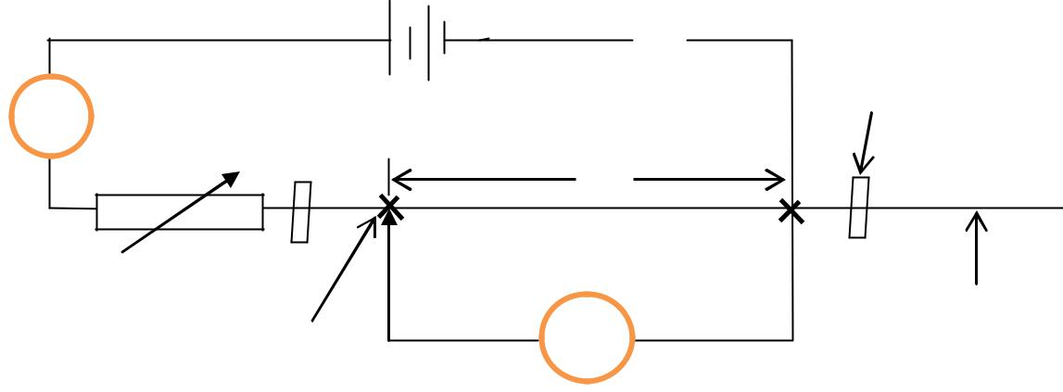

K



A

Cellotape

***x***

Rheostat

Bare wire, W

Crocodile clip V

1. Adjust the crocodile clip so that ***x*** = 0.300m.
2. Close switch K*,* and adjust the rheostat until the ammeter reading, I= 0.40 A.
3. Record the voltmeter reading, V.
4. Open switch, K.
5. Repeat procedures (b) to (e) for values of ***x*** = 0.400, 0.500, 0.600, 0.700 & 0.800 m.
6. Tabulate your results including values of
7. Plot a graph of against ***x***
8. Determine the slope, *S,* of your graph.
9. Calculate the constant, β of the bare wire W from the expression,
   * **= 1.13x10-7S**

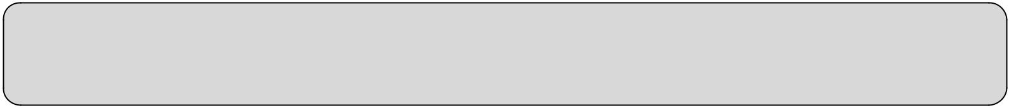

**Apparatus:** 1*Voltmeter (0-3 V);1 Ammeter (0 -1); 2 Dry cells; Jockey; 2 pieces of Cello tape; 10 pieces**of connecting wire about 30cm long;1 Metre rule; 1 Switch; Constantan bare wire (28 SWG); 1Rheostat (0 - 50Ω).*



65

**4.17: Experiment 47.**

**In this experiment, you will determine the constant, R of the resistor provided.**

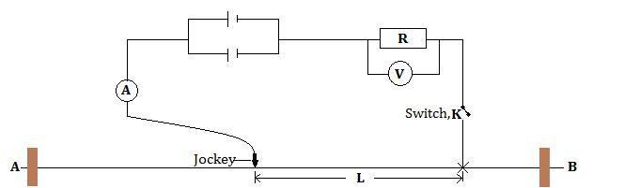

**Procedure**

1. Set up the apparatus as shown in the diagram above.
2. Starting with length, =, close the switch, K.
3. Record the voltmeter reading, and the ammeter readings, .
4. Repeat the procedures b) and c) for values of =, , , and.
5. Enter your result in the suitable table including values of and

f) Plot a graph of against .

g) Determine the gradient, ***S*** of the graph.



**Apparatus:** Two cells, Nichrome wire SWG28 (about 110 cm), 8 pieces of connecting wires, a Carbonresistor, i.e. 5 Ω, ammeter (0 – 1)A, Voltmeter (0 – 3)V, Switch, K, 2 single cell holders.



66

|  |  |
| --- | --- |
|  |  |